

Capstone Project Report
Report 4 – Software Design Specification

– Hanoi, Aug 2026 –

Table of Contents
Change Log 6
I. High Level Design 7
1. Software Architecture 7
2. Package Diagram 9
2.1 Overview 10
2.2 Back-End Package Diagram 11
2.3 Domain Package Diagram 12
2.4 Front-End Package Diagram 14
3. Database Design 15
3.1 table_name1 15
3.2 users 15
3.3 table_name3 15
II. Detailed Code Design 16
1. FE-01 Authentication 16
1.1 Class Diagram 16
1.2 Sequence Diagram 17
1.2.1 UC-01 – Sign in with Username and Password 17
1.2.2 UC-02 – Sign in with Google 18
1.2.3 UC-03 – Sign Out 19
1.2.4 UC-04 – Access Meeting via Guest Invitation 20
2. FE-02 User Management 21
2.1 Class Diagram 21
2.2 Sequence Diagram 21
2.2.1 UC-05 – View User Accounts 21
2.2.2 UC-06a – Create User Account 22
2.2.3 UC-06b – Update User Account 23
2.2.4 UC-06c – Deactivate / Reactivate User Account 24
2.2.5 UC-07 – Reset User Password 25
2.2.6 UC-08 – Assign System Role to User 26
2.2.7 UC-09 – Unlock User Account 27
3. FE-03 Role Management 28
3.1 Class Diagram 28
3.2 Sequence Diagram 28
3.2.1 UC-10 – View Role & Permission Matrix 28
3.2.2 UC-11 – Configure Role Permissions 29
3.2.3 UC-12a – Create Role 30
3.2.4 UC-12b – Update Role 31
3.2.5 UC-12c – Delete Role 32
3.2.6 UC-13 – View Audit Log 33
4. FE-04 Meeting Management 33
4.1 Class Diagram 33
4.2 Sequence Diagram 34
4.2.1 UC-14 – Create Meeting 34
4.2.2 UC-15 – Update Meeting 35
4.2.3 UC-16 – View Meeting Details 36
4.2.4 UC-17 – View Meeting List 36
4.2.5 UC-18 – Submit Meeting for Approval 37
4.2.6 UC-19 – Review Meeting Approval 38
4.2.7 UC-20 – Publish Meeting 39
4.2.8 UC-21 – Start Meeting 40
4.2.9 UC-22 – End Meeting 41
4.2.10 UC-75 – Cancel Meeting 42
5. FE-05 Agenda Management 42
5.1 Class Diagram 42
5.2 Sequence Diagram 43
5.2.1 UC-23a – Create Agenda Item 43
5.2.2 UC-23b – Update Agenda Item 44
5.2.3 UC-23c – Delete Agenda Item 44
5.2.4 UC-23d – Reorder Agenda Items 45
5.2.5 UC-24 – Set Current Agenda Item 46
5.2.6 UC-25 – Complete Agenda Item 47
5.2.7 UC-26 – View Meeting Agenda 47
5.2.8 UC-77 – Record Agenda Item Conclusion 48
6. FE-06 Meeting Participant Management 48
6.1 Class Diagram 48
6.2 Sequence Diagram 49
6.2.1 UC-27 – View Meeting Participants 49
6.2.2 UC-28a – Add Meeting Participant 49
6.2.3 UC-28b – Manage Meeting Role & Additional Permissions 50
6.2.4 UC-28c – Remove Meeting Participant 50
6.2.5 UC-29 – Respond to Meeting Invitation 51
6.2.6 UC-30 – View Participant Response Status 51
6.2.7 UC-31 – Record Attendance 52
6.2.8 UC-73 – Hand Over Chair to Another Participant 52
7. FE-07 Meeting Document Management 53
7.1 Class Diagram 53
7.2 Sequence Diagram 54
7.2.1 UC-32a – View Meeting Documents 54
7.2.2 UC-32c – Preview Meeting Document 54
7.2.3 UC-33a – Add Documents from Personal Library 55
7.2.4 UC-33a – Upload Documents to Meeting (AF-1) 56
7.2.5 UC-33b – Attach Documents to Agenda Item 57
7.2.6 UC-33c – Remove Document from Meeting 58
7.2.7 UC-33d – Detach Document from Agenda Item 59
7.2.8 UC-34 – View Personal Document Library 60
7.2.9 UC-34b – View a Locked Account's Personal Library 60
7.2.10 UC-35 – Comment on Meeting Document 61
7.2.11 UC-36 – Upload Document to Personal Library 62
7.2.12 UC-71a – Delete Document from Personal Library 62
7.2.13 UC-71b – Rename Document 63
7.2.14 UC-71c – Move Document to Folder 63
7.2.15 UC-72a – Create Folder 64
7.2.16 UC-72b – Rename Folder 65
7.2.17 UC-72c – Move Folder 66
7.2.18 UC-72d – Delete Folder 67
7.2.19 UC-74 – Confirm Document Read 67
8. FE-11 Voting Management 68
8.1 Sequence Diagram 68
8.1.1 UC-76a – Attach Documents to Vote 68
8.1.2 UC-76b – Detach Document from Vote 69
9. FE-13 Notification 69
9.1 Class Diagram 69
9.2 Sequence Diagram 70
9.2.1 UC-66 – View Notifications 70
9.2.2 UC-67a – Mark Notification as Read 70
9.2.3 UC-67b – Mark All Notifications as Read 71
9.2.4 UC-68 – Open Notification Target 72
III. Design for Non-Functional Requirements 72
1. Security Design 72
1.1 Authentication Flow 72
a. Token Design 72
b. CORS Configuration 73
1.2 Authorization & RBAC Implementation 73
1.3 Data Protection 73
2. Performance & Scalability Design 73
2.1 Caching Strategy 73
2.2 Database Query Optimization 73
IV. Other Design Specifications 73

Change Log
Date | A*  M, D | In charge | Change Description
28/10/2026 | A | HuyNT | II. Detailed Code Design: added the class diagram and the use case sequence diagrams of FE-01 to FE-07, FE-11 and FE-13 from the project repository
28/10/2026 | A | HuyNT | I.2 Package Diagram: added the overview, back-end, domain and front-end package diagrams from the project repository, with package descriptions and naming conventions
28/10/2026 | M | HuyNT | II. Detailed Code Design: grouped each feature's use case sequence diagrams under a Sequence Diagram heading; whole document switched to Times New Roman
28/10/2026 | A | HuyNT | I.1 Software Architecture: added the architecture diagram drawn from the project code and deployment, with a description of each component
*A - Added M - Modified D - Deleted

I. High Level Design

1. Software Architecture
TrustCabinet is a three-tier web application with a single back-end process. A React single-page application runs in the browser; one ASP.NET Core 10 application serves the REST API, the SignalR hubs and, in production, the built front-end from the same origin, so there is no CORS; PostgreSQL holds the data. Live updates travel over SignalR, voice and video calls go through a self-hosted LiveKit media server, and speech recognition runs on an in-house worker, so meeting audio never leaves the team's servers.
The diagram shows the test server, where every part runs as a Docker Compose service behind the Caddy reverse proxy. In development the Vite dev server proxies /api and /hubs to the back-end instead of Caddy, and SeaweedFS stands in for Cloudflare R2. Solid arrows show the direction of a call or of the data; double-headed arrows are two-way traffic; the dashed arrow is an entity mapping, not a call.
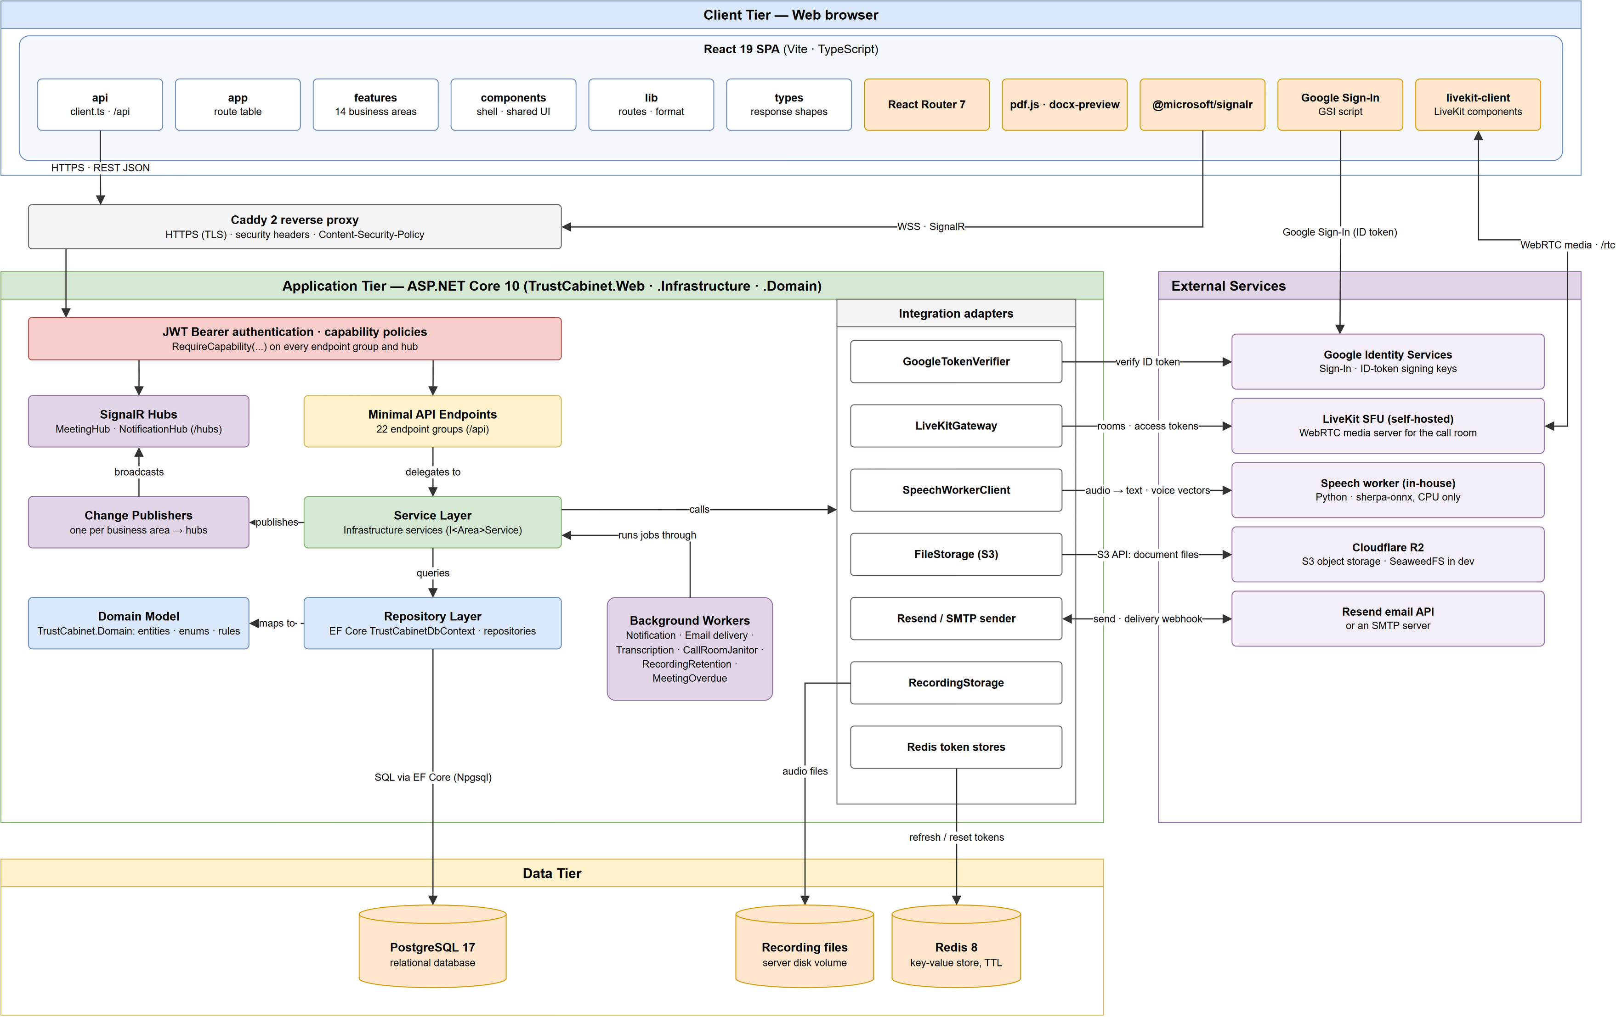
Architecture component descriptions
No | Component | Description
Client Tier
01 | React SPA (app, features, components, lib, types) | Screens of the 14 business areas, built with React 19, TypeScript and Vite. app holds the route table, features one folder per business area, components the shell and shared UI, lib framework-free helpers and types the response shapes. Capability checks here only decide what to render; the server authorises every request again.
02 | api (client.ts) | The only module that calls the back-end: relative /api paths with the access token, refreshed before it expires and retried once on a 401. The front-end has no base-URL setting because it shares one origin with the API.
03 | @microsoft/signalr | Keeps a WebSocket open to /hubs/meetings and /hubs/notifications to receive notifications and live meeting changes (agenda, attendance, participants, documents, speech).
04 | livekit-client | Joins the meeting call room on LiveKit with a token issued by the back-end and sends and receives audio and video over WebRTC.
05 | Google Sign-In (GSI) | Google's script that signs the user in with a Google account and returns an ID token, which the front-end hands to the back-end.
06 | React Router 7, pdf.js, docx-preview | Client-side routing, and in-browser preview of PDF and Word meeting documents.
Application Tier
07 | Caddy 2 reverse proxy | Entry point of the test server: terminates HTTPS, adds the security headers and the Content-Security-Policy, forwards /rtc to LiveKit and everything else to the application.
08 | JWT Bearer authentication · capability policies | Validates the access token (issuer, audience, lifetime, signing key) on every request and hub connection. Each endpoint group requires a capability through RequireCapability; capabilities belong to roles that an administrator edits at run time.
09 | Minimal API Endpoints | 22 endpoint groups under /api: authentication, users, roles and permissions, meetings, agenda, participants, attendance, documents and comments, personal library, calls, recordings, transcripts, Voice ID, notifications and the email webhook. They read the request, call the service layer and answer with an HTTP status and an MSGnn message code.
10 | SignalR Hubs | MeetingHub and NotificationHub push events to the connected browsers; a user only joins the groups of the meetings and notifications they may see.
11 | Change Publishers | Called by a service after a change is saved; broadcast the change to the matching hub group (agenda, attendance, participants, meeting documents, capabilities, speech).
12 | Service Layer | Business logic of each area in TrustCabinet.Infrastructure, behind the interfaces declared in TrustCabinet.Domain: meeting lifecycle and approval, agenda, participants, documents, recordings, transcripts, Voice ID, notifications and the audit log.
13 | Repository Layer | EF Core TrustCabinetDbContext and one repository per area. The schema is code-first (migrations), enums are stored as strings and keys are UUID v7.
14 | Domain Model | TrustCabinet.Domain: entities, enums, business rules and the service and repository interfaces. It has no EF Core dependency.
15 | Background Workers | Hosted services in the same process: dispatching notifications, sending queued emails, transcribing recordings one at a time, reconciling call rooms with LiveKit every 30 seconds, deleting recordings past their retention period, and cancelling meetings nobody started a day after their planned start.
16 | Integration adapters | One class per outside system, so services never call a third-party SDK directly: GoogleTokenVerifier, LiveKitGateway, SpeechWorkerClient, FileStorage (S3 API), the Resend and SMTP email senders, RecordingStorage (server disk) and the Redis token stores.
Data Tier
17 | PostgreSQL 17 | Main relational database: users, roles, meetings, agenda, participants, document records, recordings, transcripts, notifications and the audit log.
18 | Redis 8 | Refresh tokens and password-reset tokens, removed automatically when their TTL runs out. Losing this data only signs users out.
19 | Recording files | Audio recordings of meetings on a server disk volume, erased when their retention period ends.
External Services
20 | Google Identity Services | Signs users in with Google. The back-end verifies the ID token against Google's signing keys and links it to an existing account with the same email.
21 | LiveKit SFU (self-hosted) | WebRTC media server for the meeting call room. The back-end creates rooms and issues access tokens through LiveKit's server API; browsers exchange audio and video with it directly.
22 | Speech worker (in-house) | Python service (sherpa-onnx, CPU only) that turns Vietnamese speech into text, separates the speakers and computes voice vectors for Voice ID. It stores nothing and calls no outside AI service.
23 | Cloudflare R2 | S3-compatible object storage for the files of meeting documents and personal libraries on the test server; SeaweedFS offers the same S3 API in development.
24 | Resend email API | Sends meeting invitations and password-reset emails (an SMTP server can be used instead) and reports the delivery status back through a webhook.

2. Package Diagram
The package diagram is drawn from the current code (project references, using directives and frontend imports), as four views: the overview of the whole solution, the back-end, the domain, and the front-end. Dashed arrows are UML dependencies: «import» is a project reference, «use» is a direct use of another project's namespace or, between frontend and backend, the HTTP and SignalR calls.
Naming conventions: back-end packages are named after the business area; inside them, interfaces are I<Name>, services <Area>Service, repositories <Area>Repository, DI registration <Area>ServiceCollectionExtensions, request/response records <Area>Contracts and business rules <Area>Rules. Front-end features are lower-case folders; components are PascalCase .tsx files and hooks use<Name>.

2.1 Overview
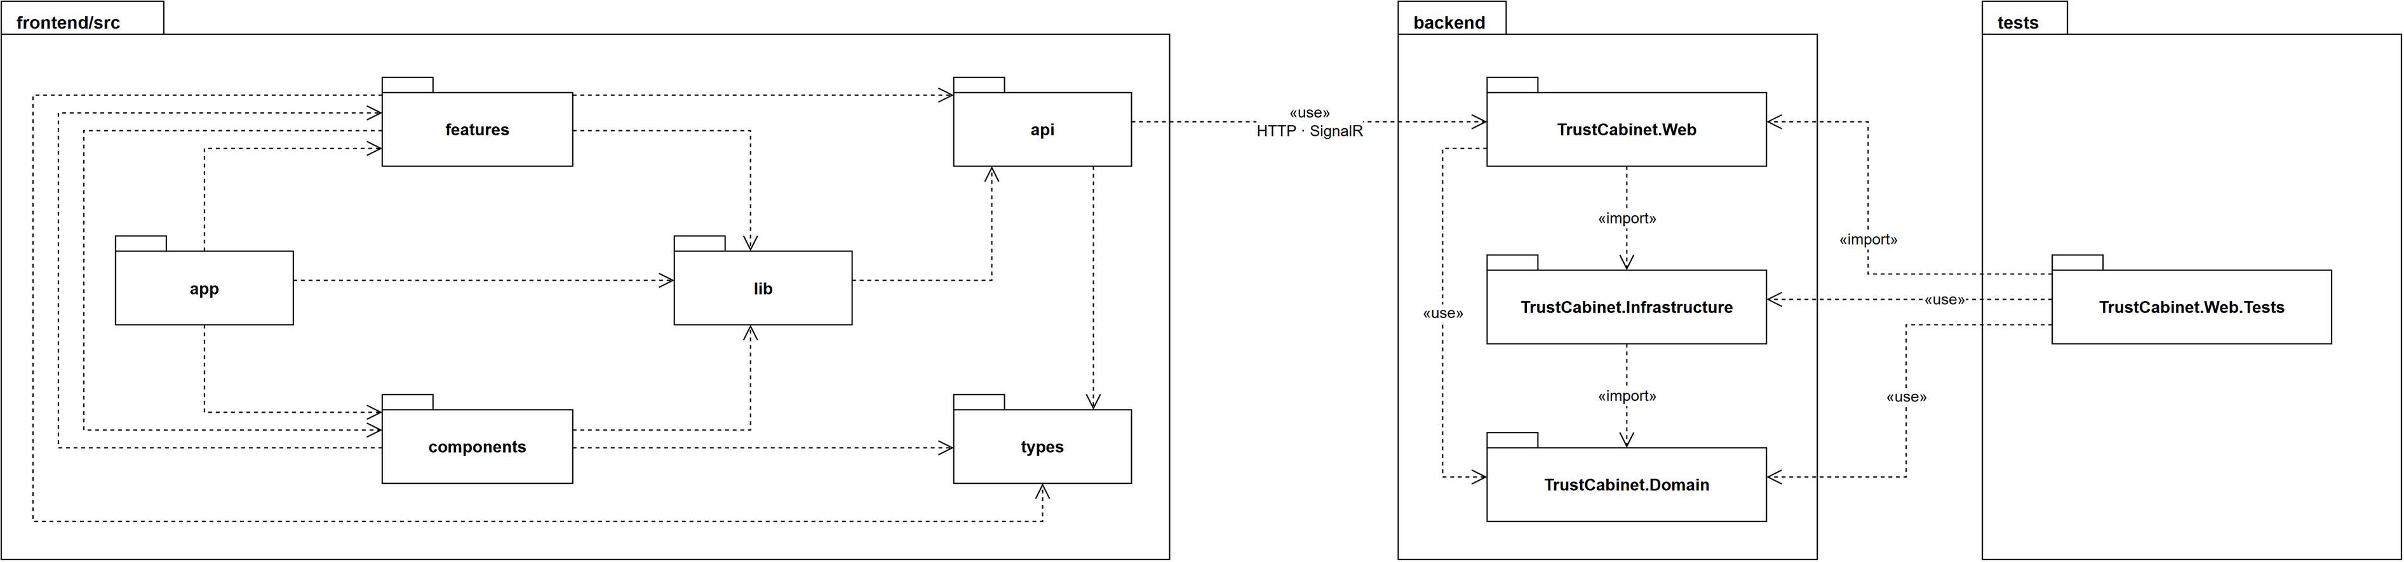
Package descriptions
No | Package | Description
frontend/src
01 | app | Route table (App.tsx): maps every URL to its screen and keeps all signed-in routes under the authentication guard.
02 | features | One folder per business area (14 features). Each holds its pages, dialogs, panels and hooks. See 2.4.
03 | components | Application shell and shared UI used by every feature: AppShell, AppSidebar, Dialog, ConfirmDialog, Select, Badge, Icon.
04 | lib | Framework-free helpers: the central route map (routes.ts), date and number formatting, error mapping, avatars.
05 | api | HTTP layer: client.ts calls the relative /api paths with the session token, plus one module per endpoint group. The only package that talks to the backend, over HTTP and SignalR.
06 | types | TypeScript types mirroring the backend response shapes, one file per endpoint group.
backend
07 | TrustCabinet.Web | ASP.NET Core 10 host: Minimal API endpoints, SignalR hubs and background workers. In production it also serves the built frontend. Imports TrustCabinet.Infrastructure.
08 | TrustCabinet.Infrastructure | EF Core DbContext, entity configurations, migrations and seed data; implements the domain services and repositories and the external integrations (PostgreSQL, LiveKit, file storage, email, speech worker). Imports TrustCabinet.Domain.
09 | TrustCabinet.Domain | Entities, enums, business rules and the service/repository interfaces of each business area. No EF Core dependency.
tests
10 | TrustCabinet.Web.Tests | xUnit tests that boot the web application in memory and check endpoints, business rules, the database model and the message code catalogue.

2.2 Back-End Package Diagram
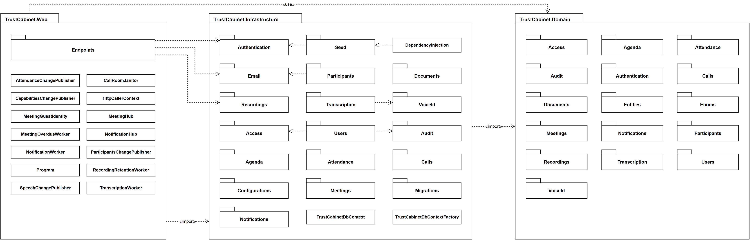
Package descriptions
No | Package | Description
TrustCabinet.Web
01 | Endpoints | Minimal API endpoint groups, one per area (AuthEndpoints, MeetingEndpoints, AgendaEndpoints, …): bind the request, re-authorize the caller and call the domain service. Naming: <Area>Endpoints.
02 | MeetingHub, NotificationHub | SignalR hubs under /hubs. They push "this changed" events; the client refetches through the API, which re-authorizes.
03 | *ChangePublisher | AttendanceChangePublisher, CapabilitiesChangePublisher, ParticipantsChangePublisher, SpeechChangePublisher: send a hub event after a change is committed.
04 | Workers | Hosted background services: MeetingOverdueWorker (cancels meetings never started), NotificationWorker (due reminders), RecordingRetentionWorker (erases expired recordings), TranscriptionWorker (transcript queue), CallRoomJanitor (reconciles call rooms with LiveKit).
05 | Program, HttpCallerContext, MeetingGuestIdentity | Program builds the pipeline; HttpCallerContext gives the audit log the caller's IP address; MeetingGuestIdentity maps a guest token to its meeting and invitation (UC-04).
TrustCabinet.Infrastructure
06 | Access | Roles and the role-permission matrix: RoleService, RolePermissionService, their repositories and the administrator invariant guard.
07 | Agenda | Agenda item service and repository; notifies the presenter of the current item.
08 | Attendance | Attendance service and repository.
09 | Audit | Writes audit log entries.
10 | Authentication | Password and Google sign-in, JWT issuing, password hashing, refresh and password-reset tokens.
11 | Calls | Call rooms and call sessions; LiveKitGateway talks to the LiveKit media server.
12 | Configurations | One IEntityTypeConfiguration per entity. Naming: <Entity>Configuration.
13 | Documents | Meeting documents, comments and personal library; FileStorage for the S3-compatible object store; purge of orphan files.
14 | Email | Email queue and delivery worker; meeting invitations with a calendar attachment.
15 | Meetings | Meeting create/update, lifecycle (submit, approve, publish, start, end, cancel) and overdue handling.
16 | Migrations | EF Core code-first migrations and the model snapshot.
17 | Notifications | In-app notification service and repository.
18 | Participants | Participants, meeting roles and invitation responses.
19 | Recordings | Recording service, storage and per-microphone speech clips.
20 | Seed | Reference data and development seed data.
21 | Transcription | Client of the in-house speech worker; transcripts.
22 | Users | User account service and repository.
23 | VoiceId | Voice samples under consent; the voiceprint is stored encrypted (VoiceprintProtector).
24 | DependencyInjection | Registers the database and the infrastructure services.
25 | TrustCabinetDbContext | The application's only EF Core DbContext.
26 | TrustCabinetDbContext​Factory | Design-time factory used only by the dotnet ef tooling.

2.3 Domain Package Diagram
The arrows to Entities and Enums are omitted for readability; almost every domain package depends on them.
Package descriptions
No | Package | Description
01 | Access | Built-in roles and the interfaces of the role and role-permission services and repositories.
02 | Agenda | Agenda contracts and rules, guest access to the agenda.
03 | Attendance | Attendance contracts and rules.
04 | Audit | IAuditService and ICallerContext.
05 | Authentication | Sign-in interfaces and results: password hasher, refresh and reset token stores, Google token verifier.
06 | Calls | Call contracts and interfaces.
07 | Documents | Document, comment and personal library contracts; document file rules.
08 | Entities | Entity classes mapped to the database tables (Meeting, AgendaItem, Document, CallSession, …); the Common sub-package holds the Entity base class.
09 | Enums | Enumerations, stored as strings in the database.
10 | Meetings | Meeting service and repository interfaces, contracts, guest session and invitation recipient policy.
11 | Notifications | Notification service and repository interfaces and contracts.
12 | Participants | Participant contracts and rules.
13 | Recordings | Recording and speech clip contracts.
14 | Transcription | Transcription contracts.
15 | Users | User account service and repository interfaces and results.
16 | VoiceId | Voice ID contracts.

2.4 Front-End Package Diagram
Dependencies between features are omitted for readability (meetings and calls use almost every other feature; every feature uses auth).
Package descriptions
No | Package | Description
01 | access | Administration screens: users and the role-permission matrix, with their form dialogs.
02 | agenda | Meeting agenda panel, agenda item dialog and item conclusions.
03 | attendance | Attendance panel of a meeting.
04 | auth | Sign-in (password and Google), password reset, the session context and the RequireAuth / RequireCapability guards.
05 | calendar | Calendar view of the schedule with filters and date picker.
06 | calls | Meeting room: video call over LiveKit, devices, picture-in-picture, room roles.
07 | documents | Meeting documents panel, document viewer, comments and the personal library page.
08 | meetings | Meeting list, create/edit form, meeting dialogs and status badge.
09 | notifications | Notification bell and panel; the provider listens on /hubs/notifications.
10 | participants | Participants panel, roster and invitation responses (RSVP).
11 | recordings | Recordings panel, recorder, speakers and transcript view.
12 | speech | Per-microphone capture and the speech panel.
13 | uploads | Upload tray and store for document uploads in progress.
14 | voice | Voice ID enrolment page.

3. Database Design
[Provide the files description, database table relationship & table descriptions like example below]
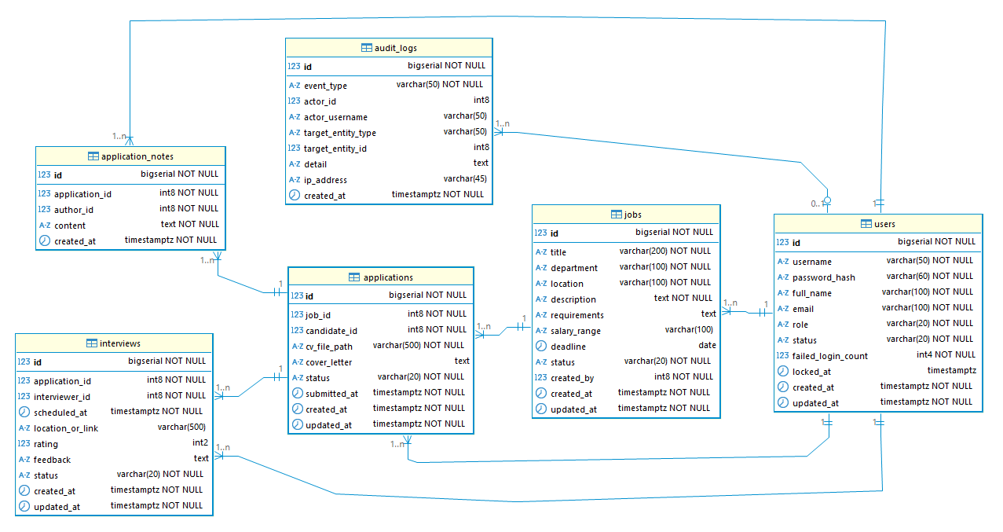

3.1 table_name1
[Add one table block per additional entity following the same structure.]
Column | Type | Constraints | Notes
{{COLUMN}} | {{TYPE}} | {{CONSTRAINTS}} | {{NOTES}}
created_at | TIMESTAMP | NOT NULL, DEFAULT NOW()
updated_at | TIMESTAMP | NOT NULL

3.2 users
Column | Type | Constraints | Notes
id | BIGSERIAL | PRIMARY KEY | Auto-increment
username | VARCHAR(50) | NOT NULL, UNIQUE | Login identifier; [a-zA-Z0-9_] only
password_hash | VARCHAR(60) | NOT NULL | BCrypt hash; never store plaintext
full_name | VARCHAR(100) | NOT NULL
email | VARCHAR(100) | NOT NULL, UNIQUE
…

3.3 table_name3
…

II. Detailed Code Design
This section presents, for each feature, its design class diagram followed by the sequence diagram of each use case. The diagrams are maintained in the project repository (docs/07-classdiagram and docs/06-sequencediagram).

1. FE-01 Authentication

1.1 Class Diagram

1.2 Sequence Diagram

1.2.1 UC-01 – Sign in with Username and Password

1.2.2 UC-02 – Sign in with Google
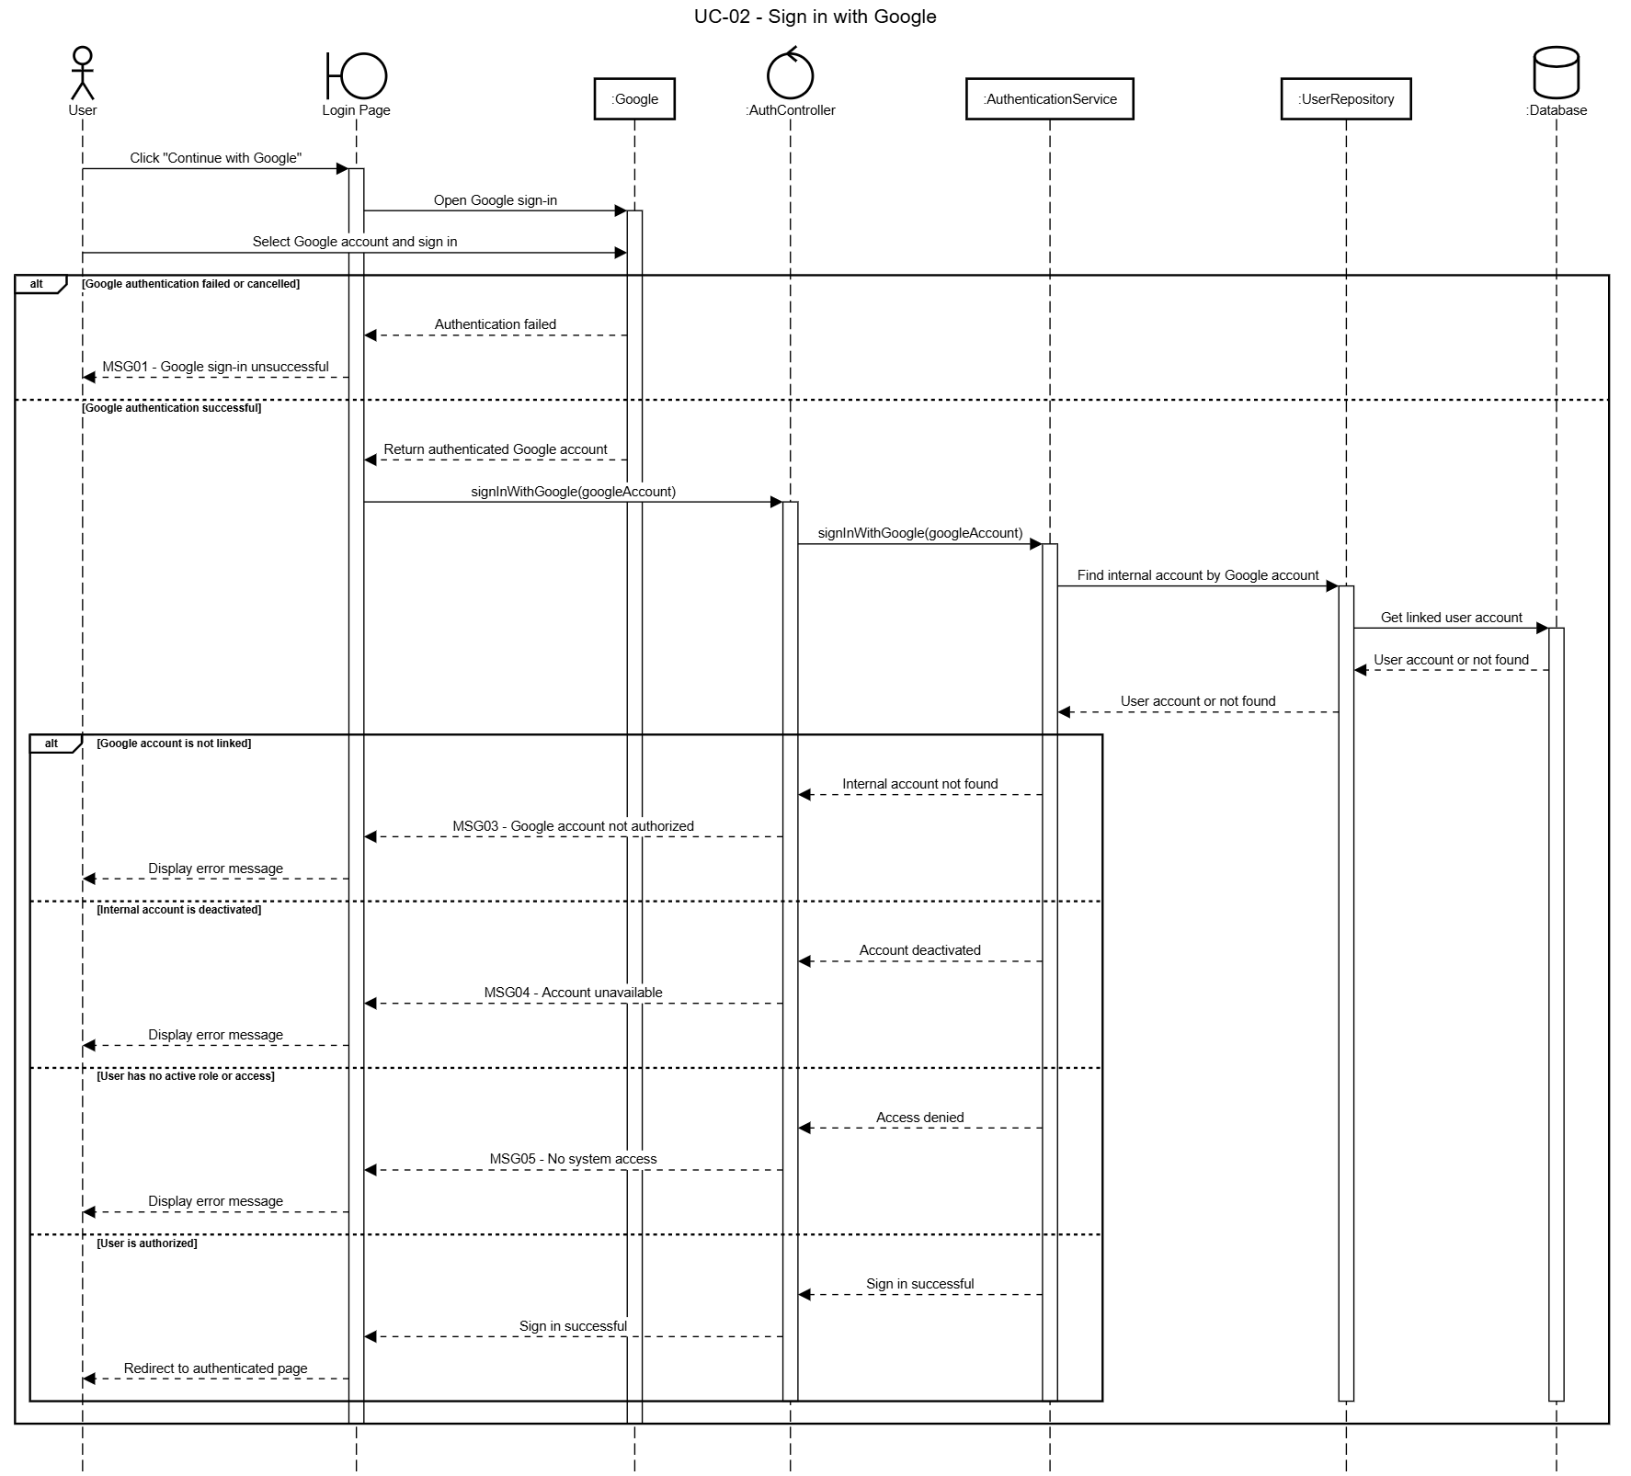

1.2.3 UC-03 – Sign Out
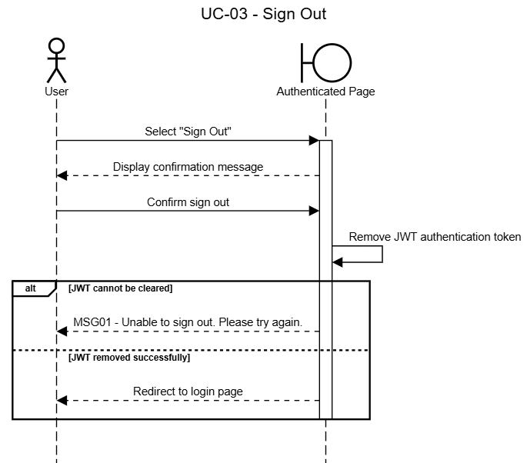

1.2.4 UC-04 – Access Meeting via Guest Invitation
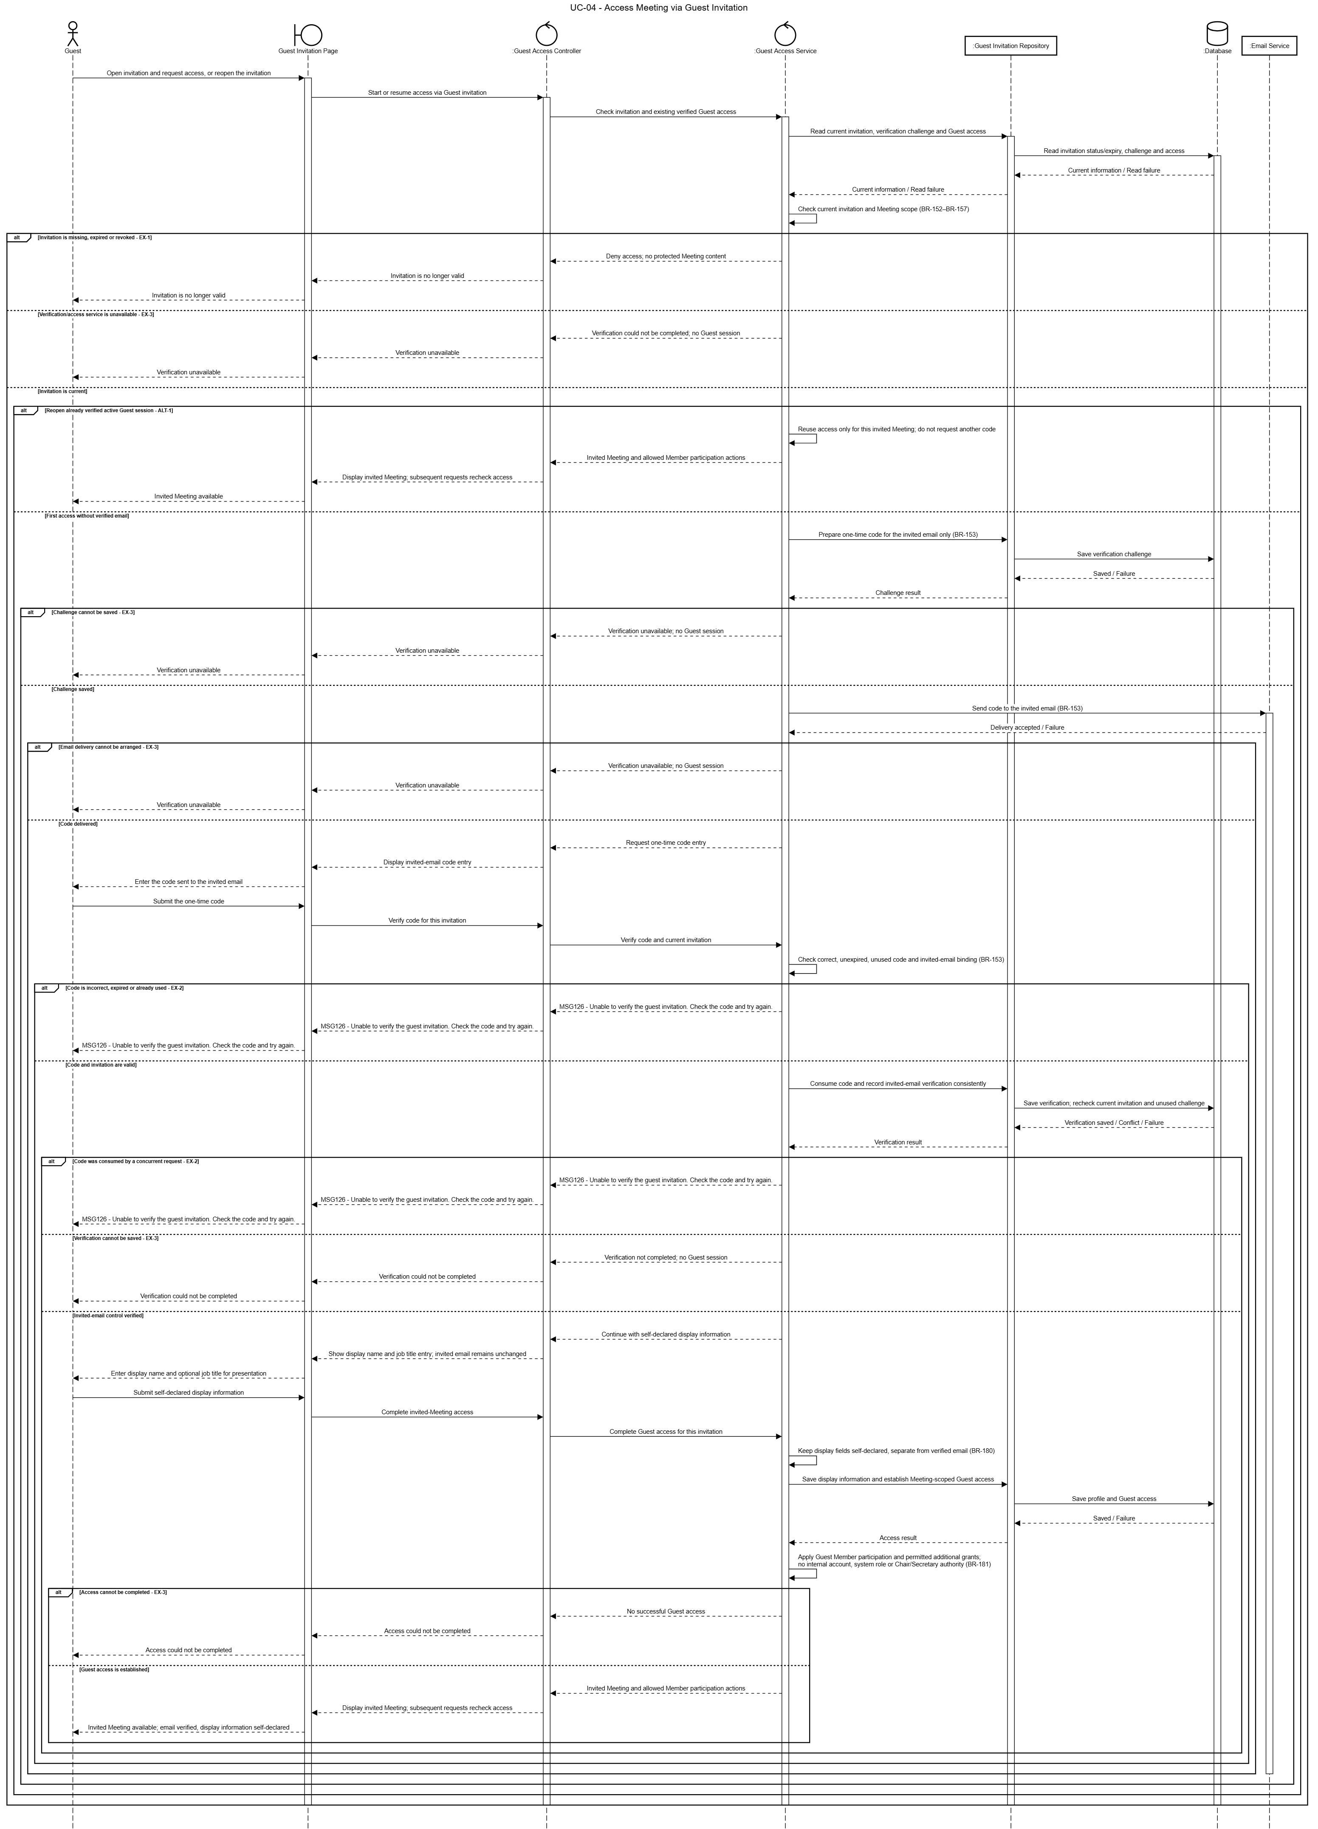

2. FE-02 User Management

2.1 Class Diagram
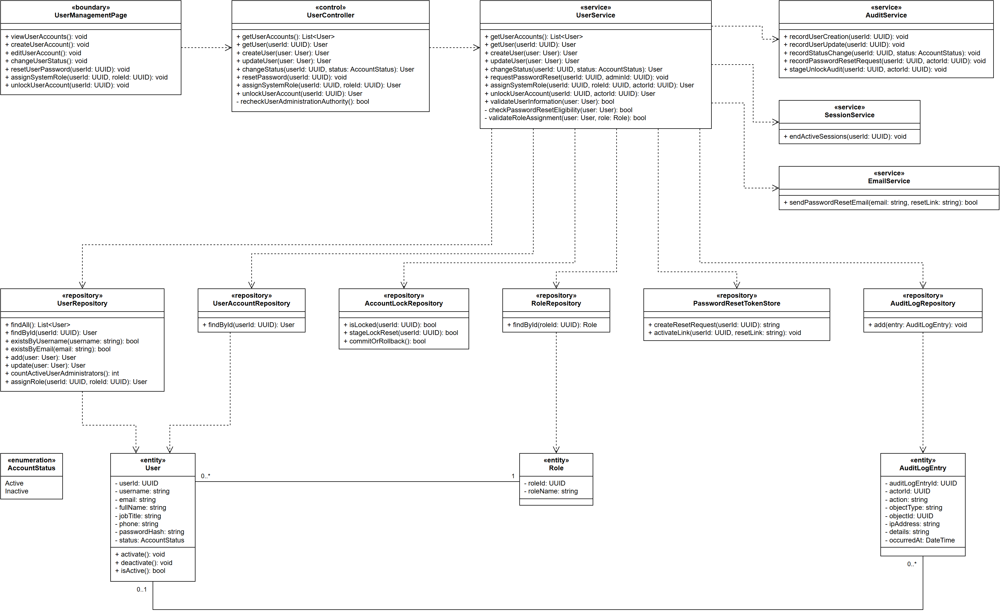

2.2 Sequence Diagram

2.2.1 UC-05 – View User Accounts
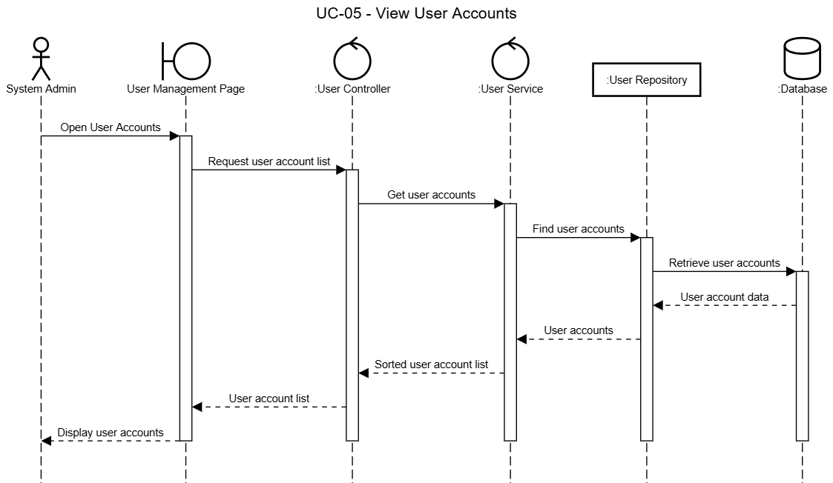

2.2.2 UC-06a – Create User Account
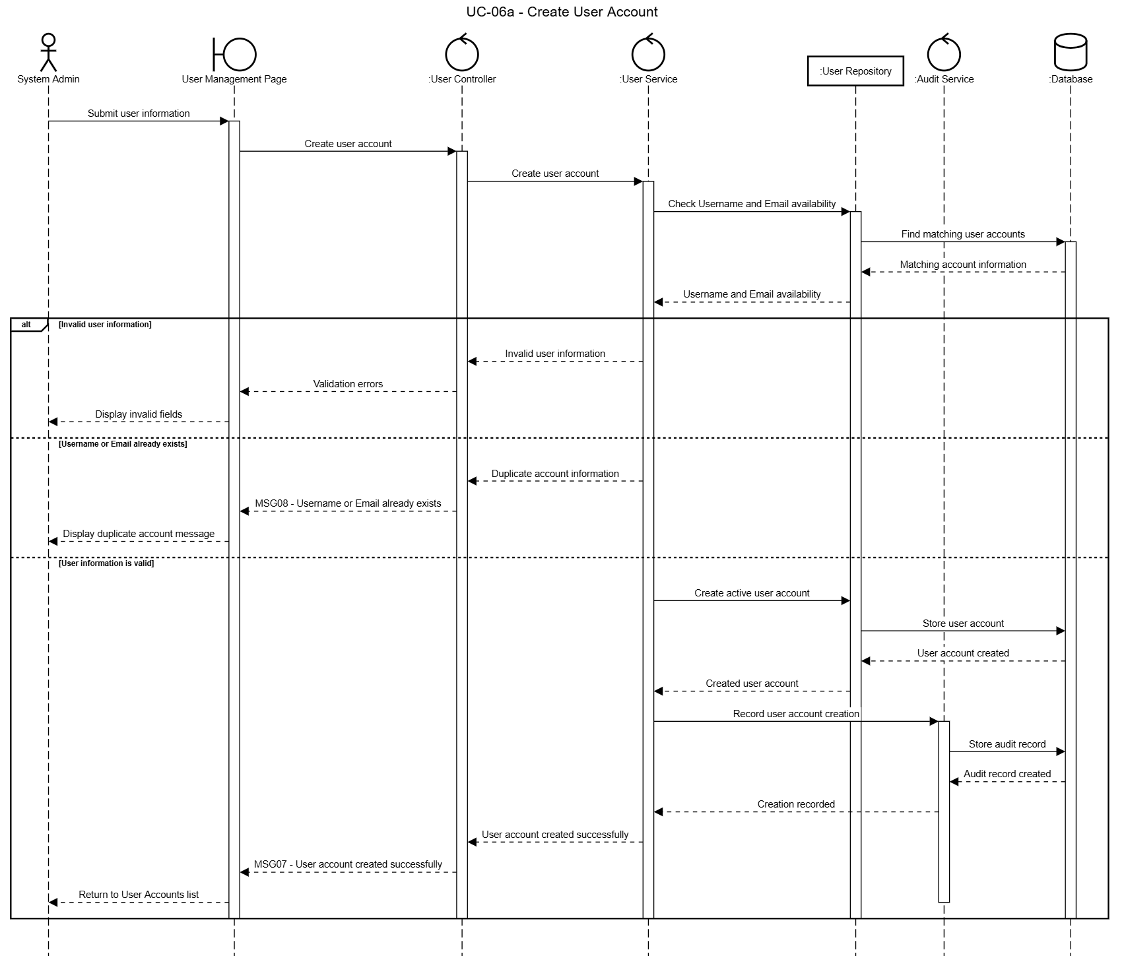

2.2.3 UC-06b – Update User Account
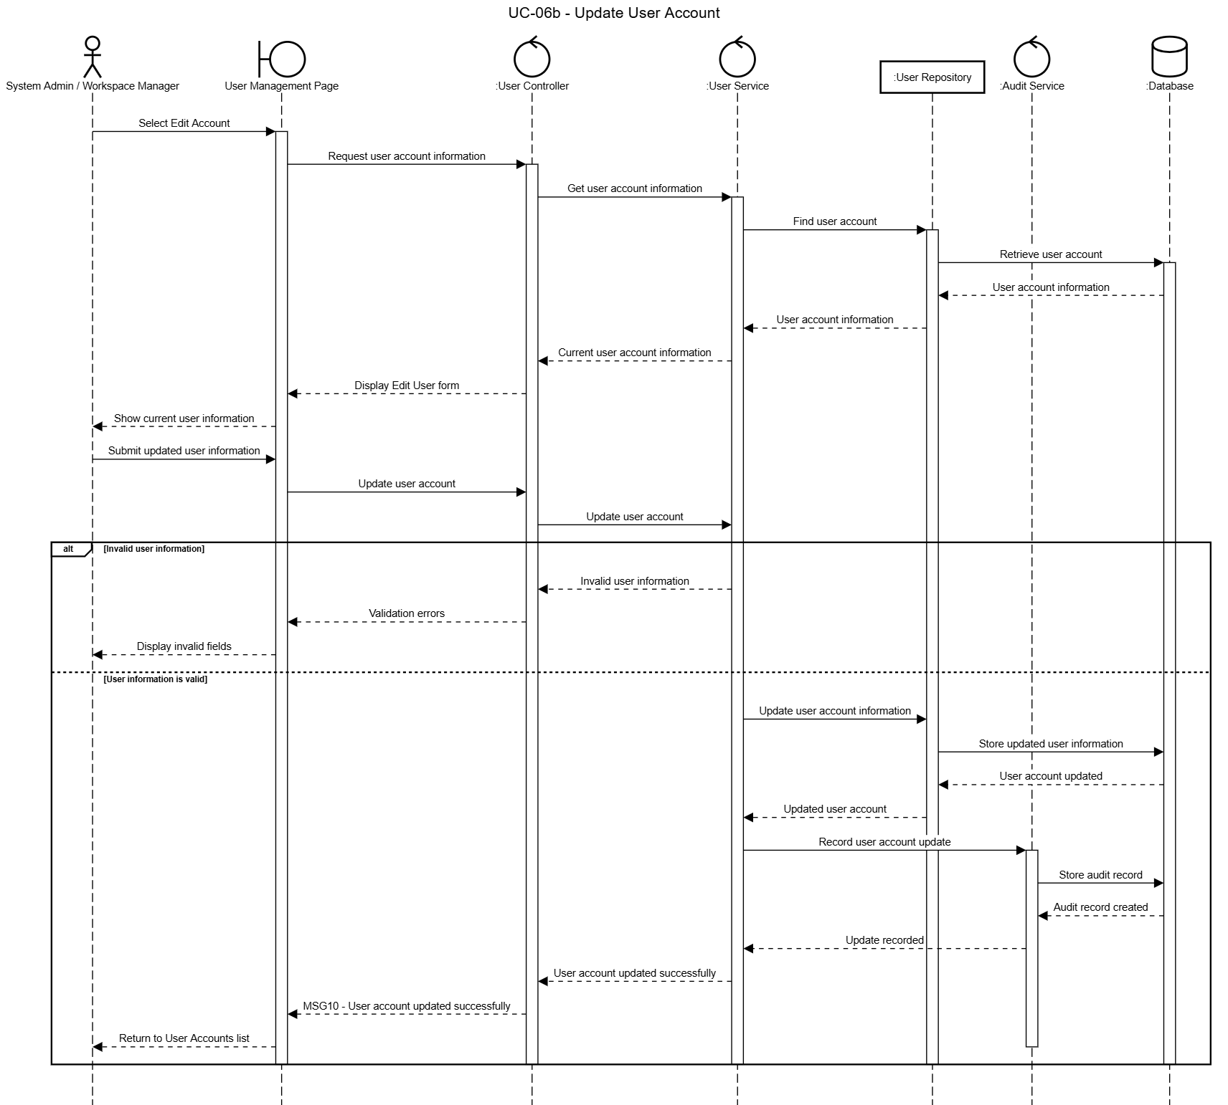

2.2.4 UC-06c – Deactivate / Reactivate User Account
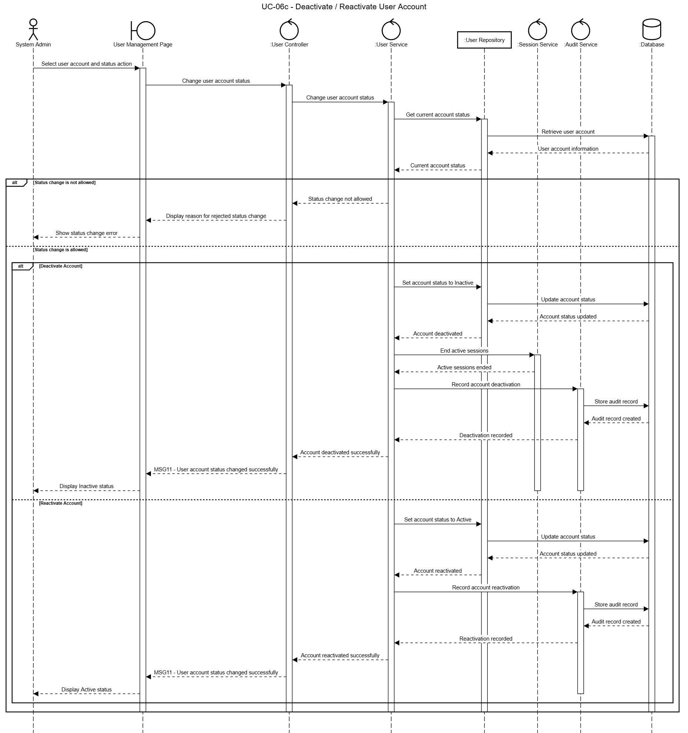

2.2.5 UC-07 – Reset User Password
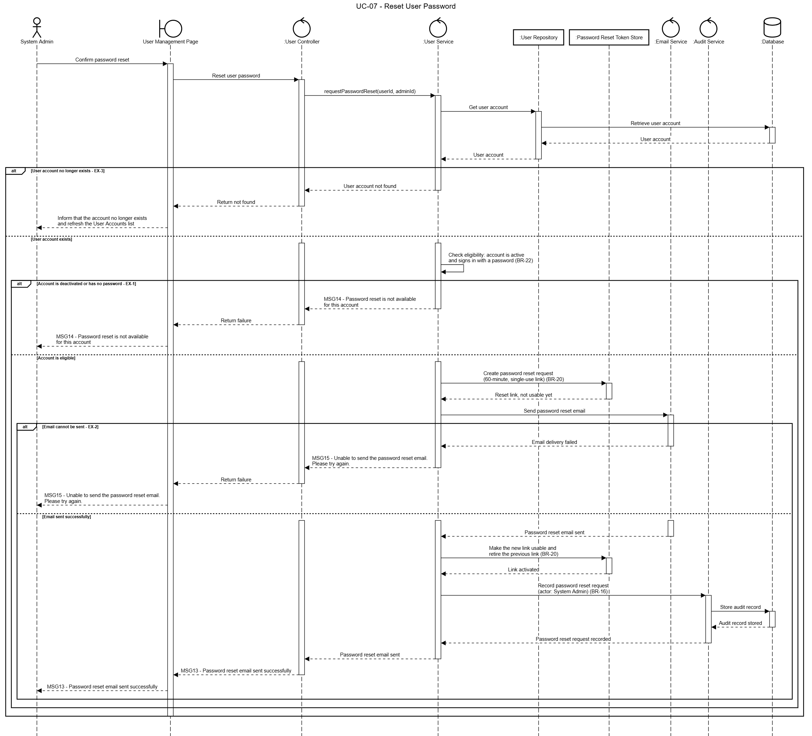

2.2.6 UC-08 – Assign System Role to User
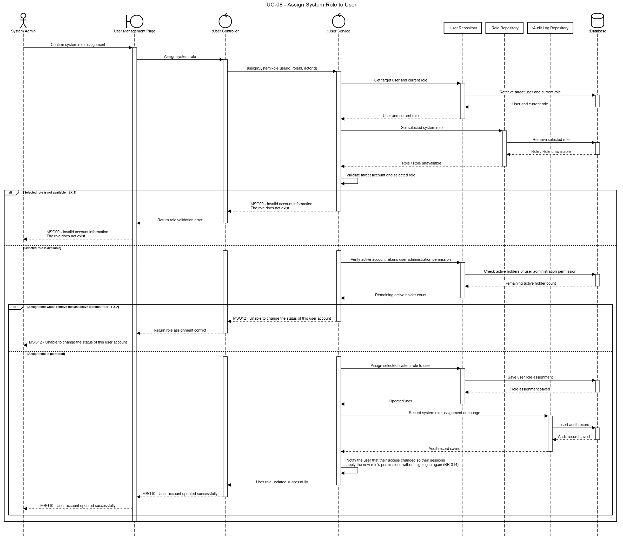

2.2.7 UC-09 – Unlock User Account
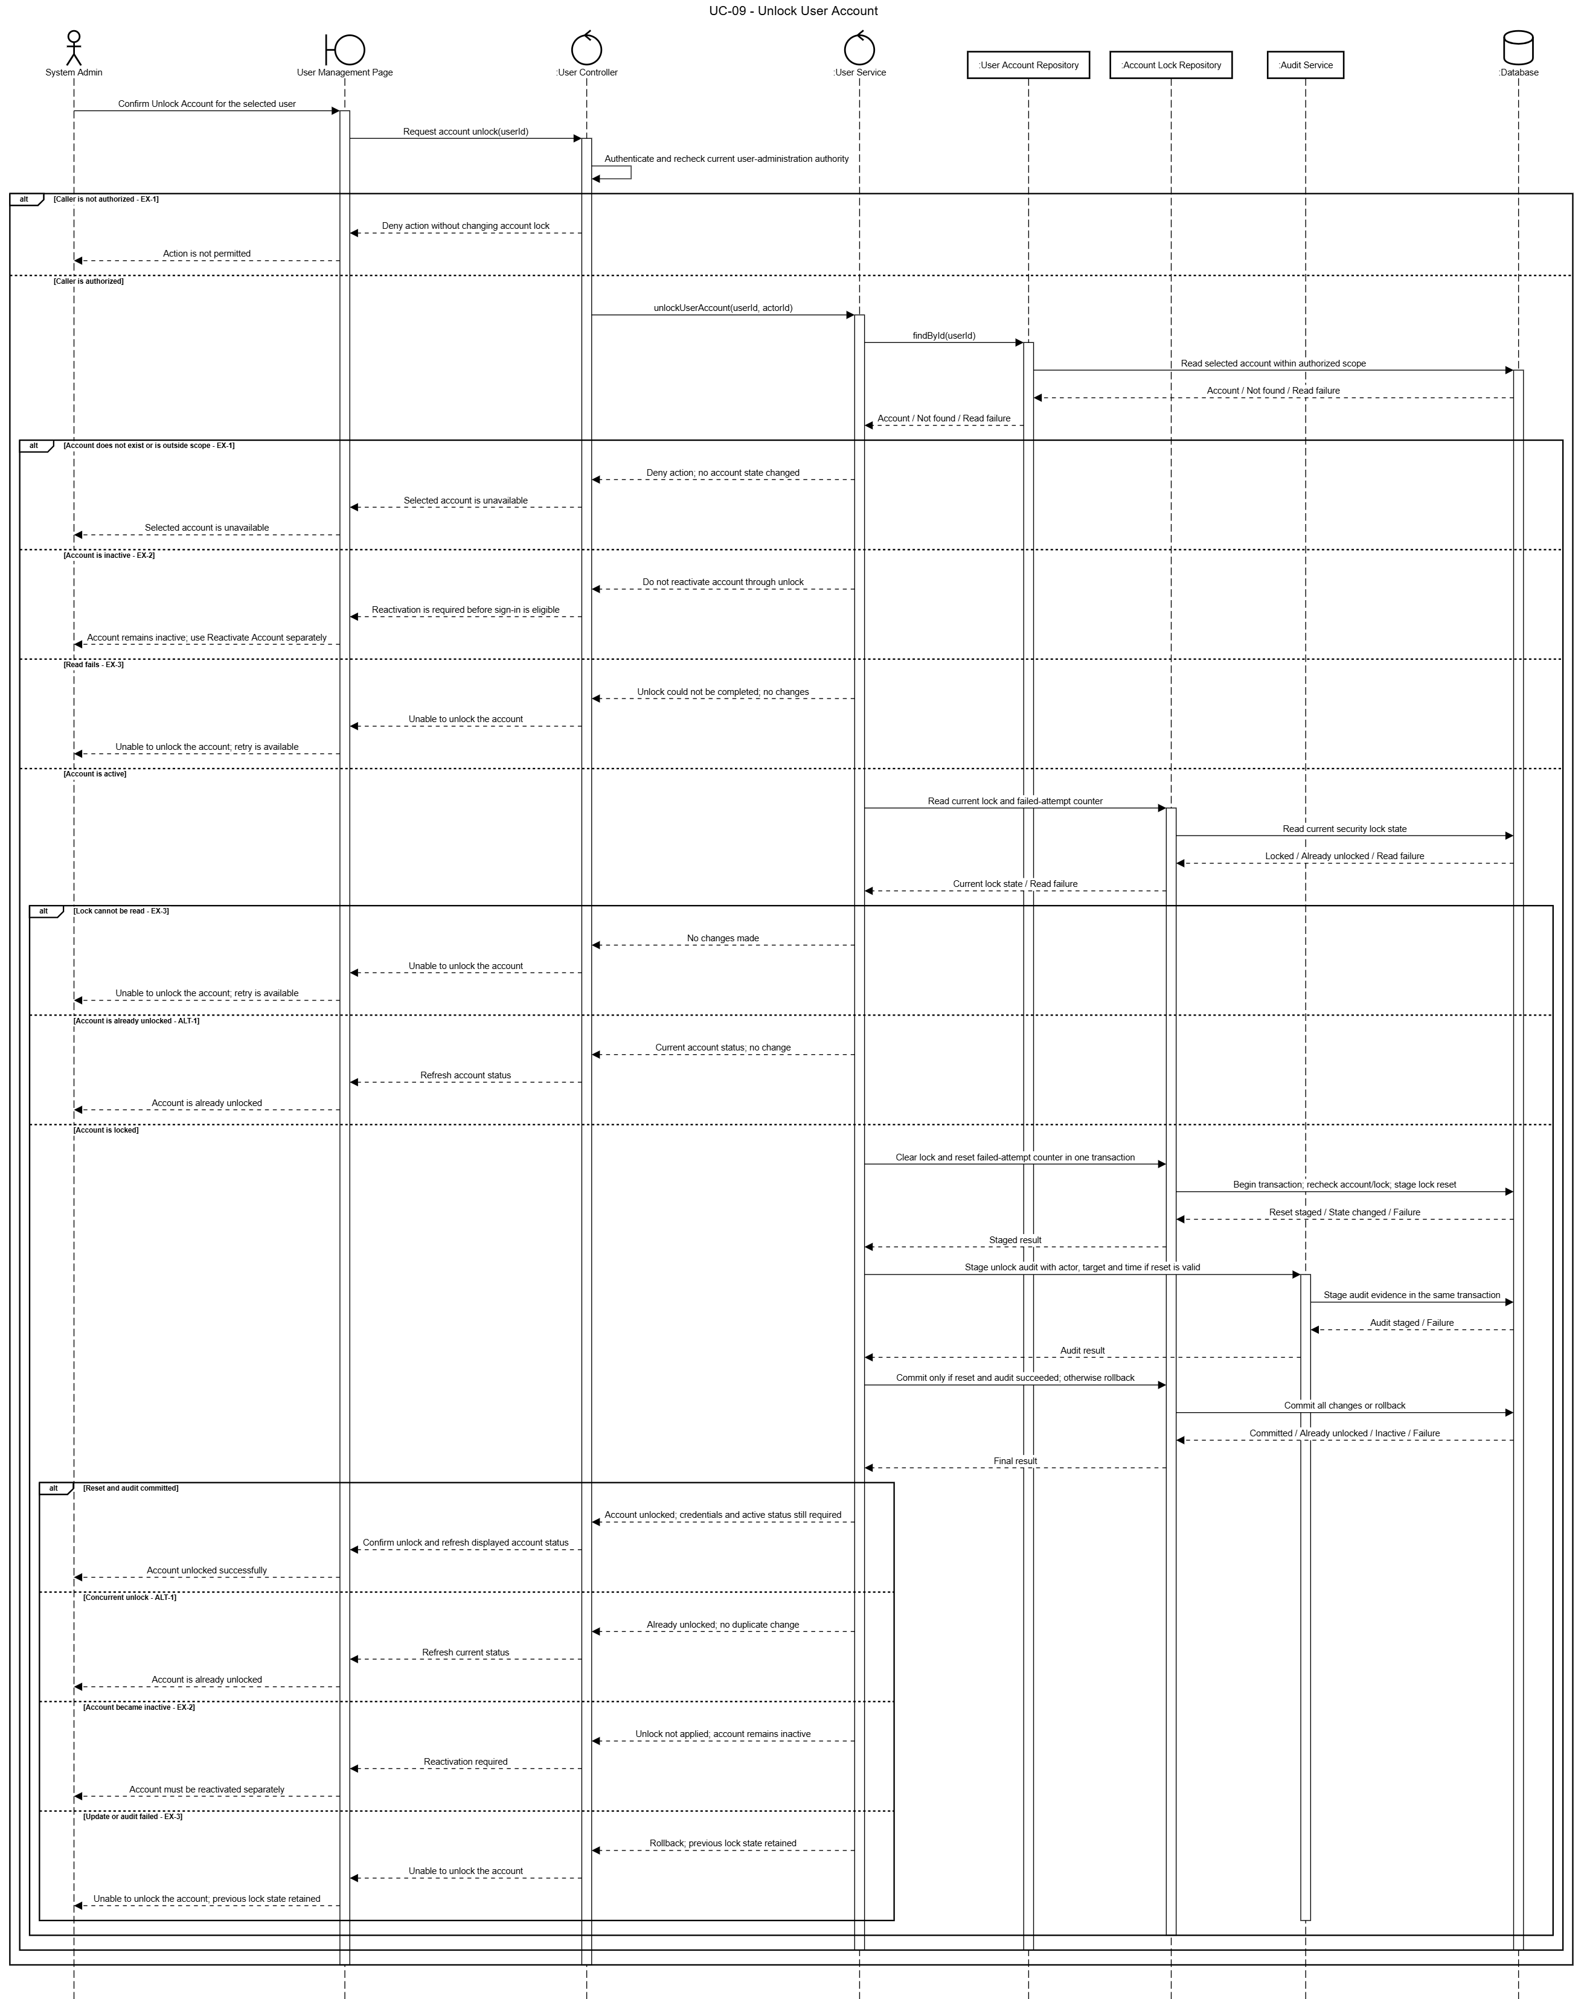

3. FE-03 Role Management

3.1 Class Diagram
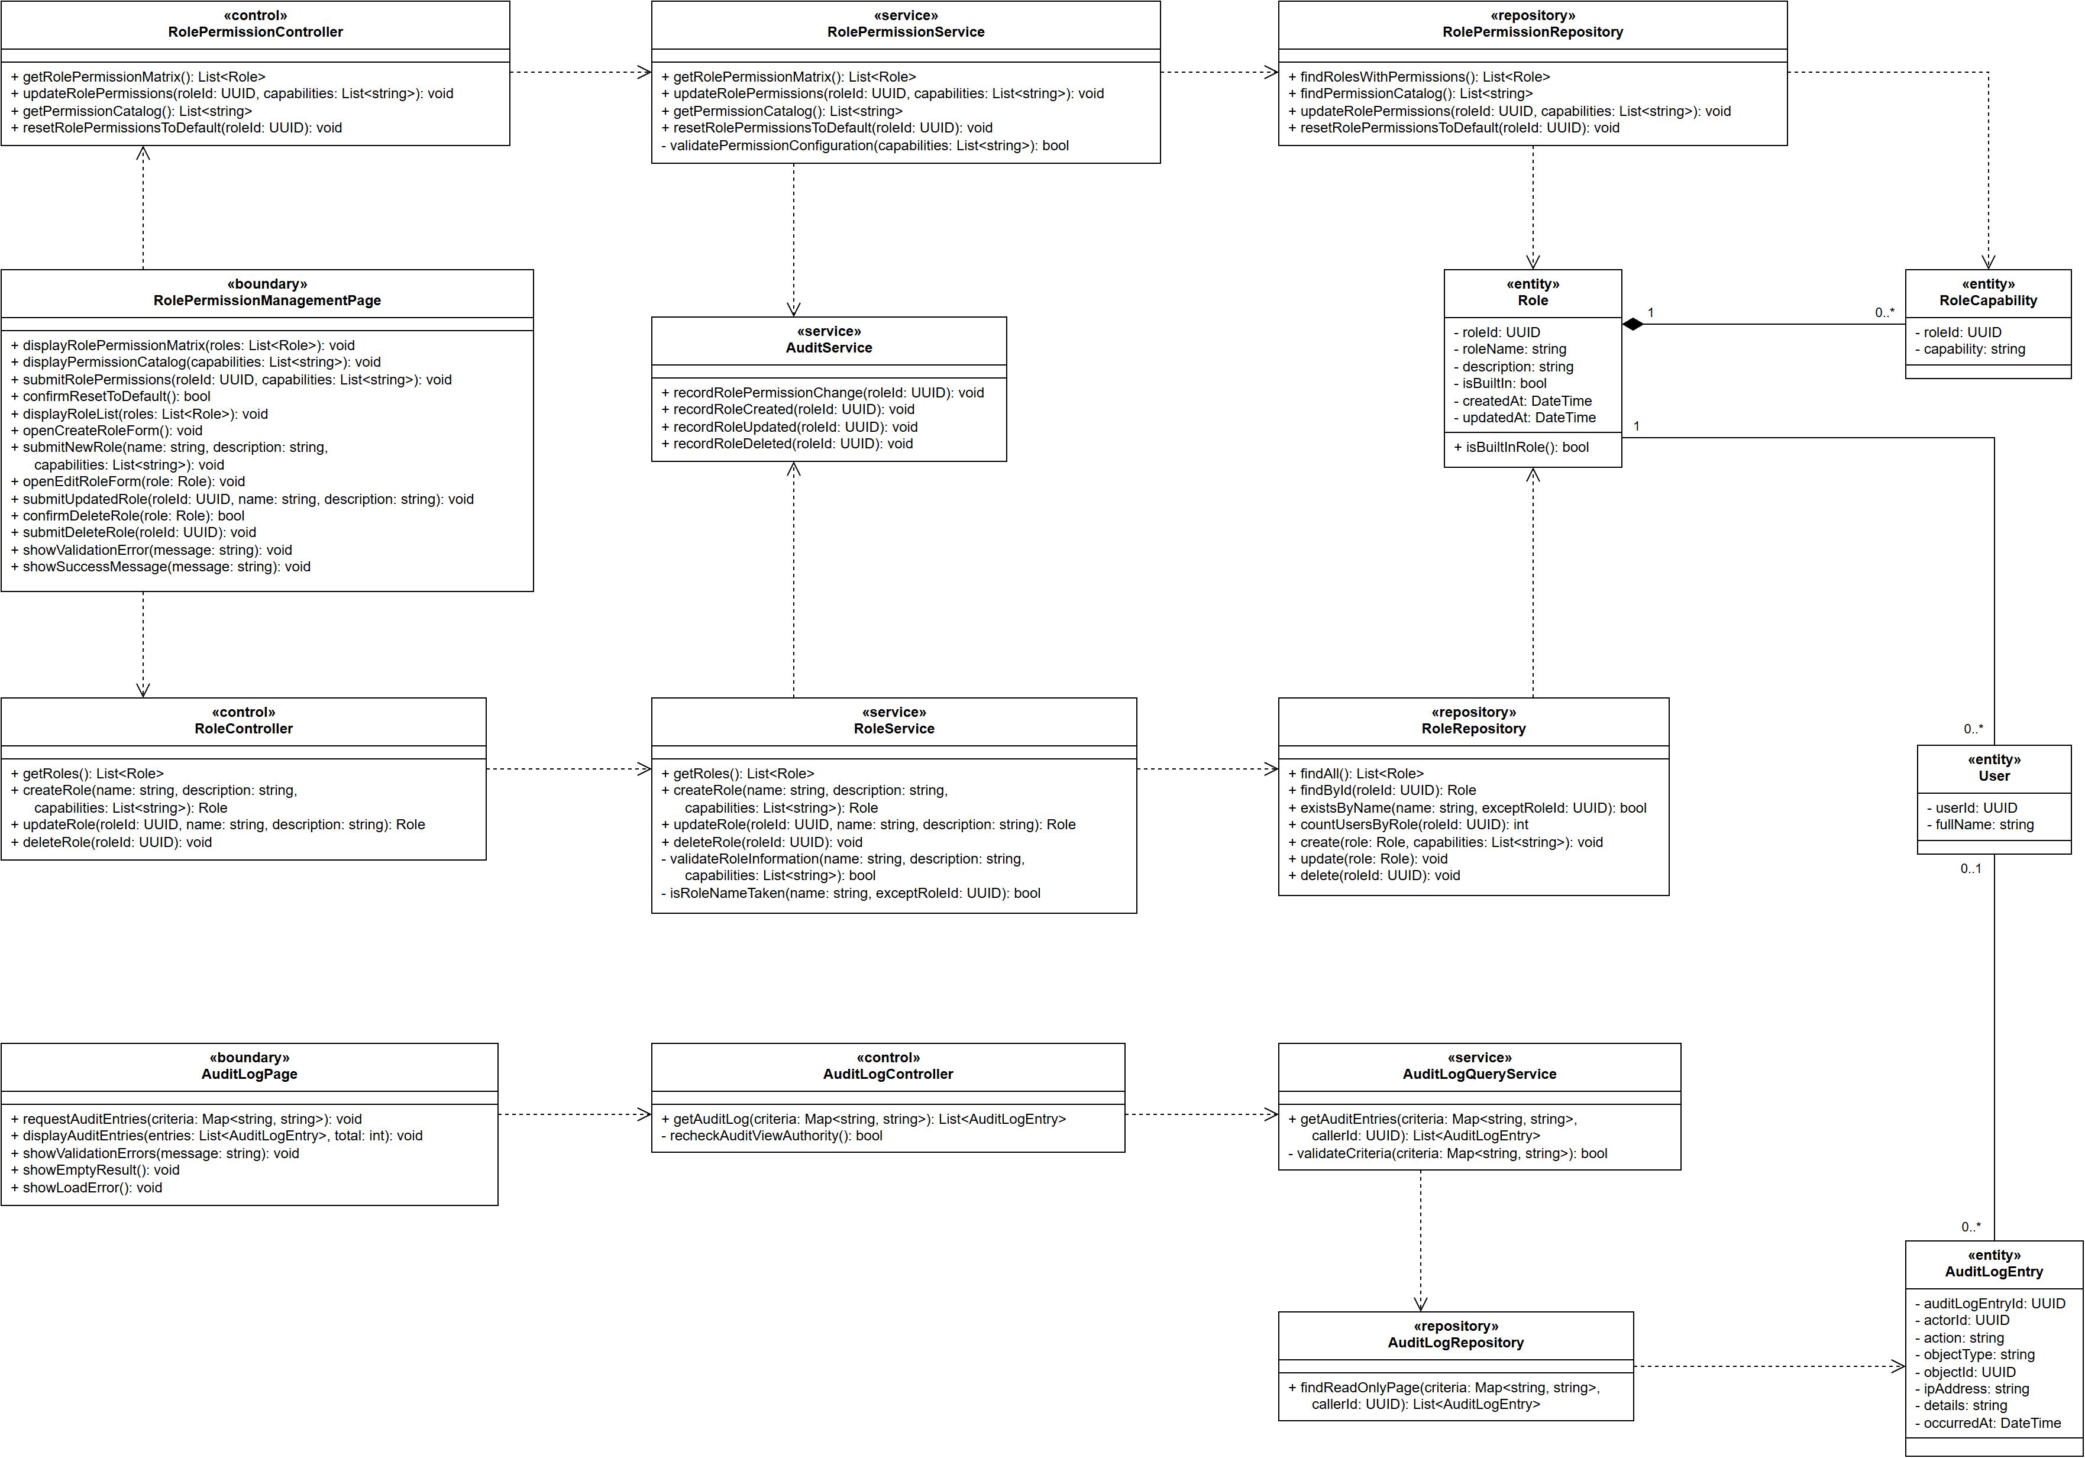

3.2 Sequence Diagram

3.2.1 UC-10 – View Role & Permission Matrix
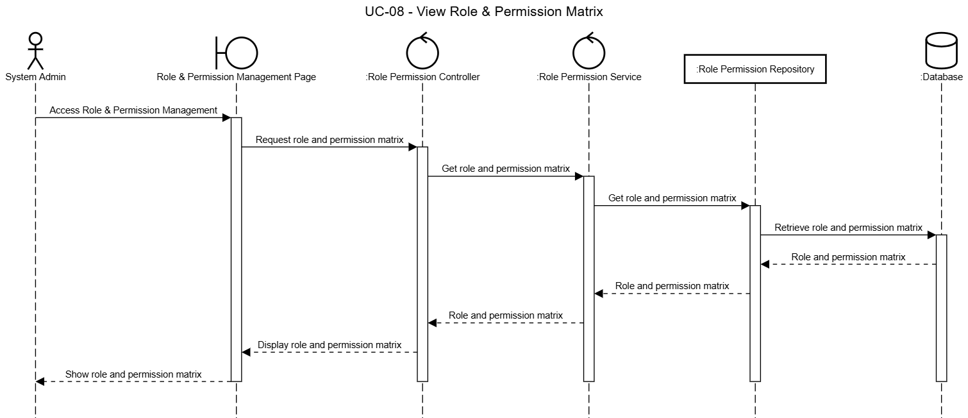

3.2.2 UC-11 – Configure Role Permissions
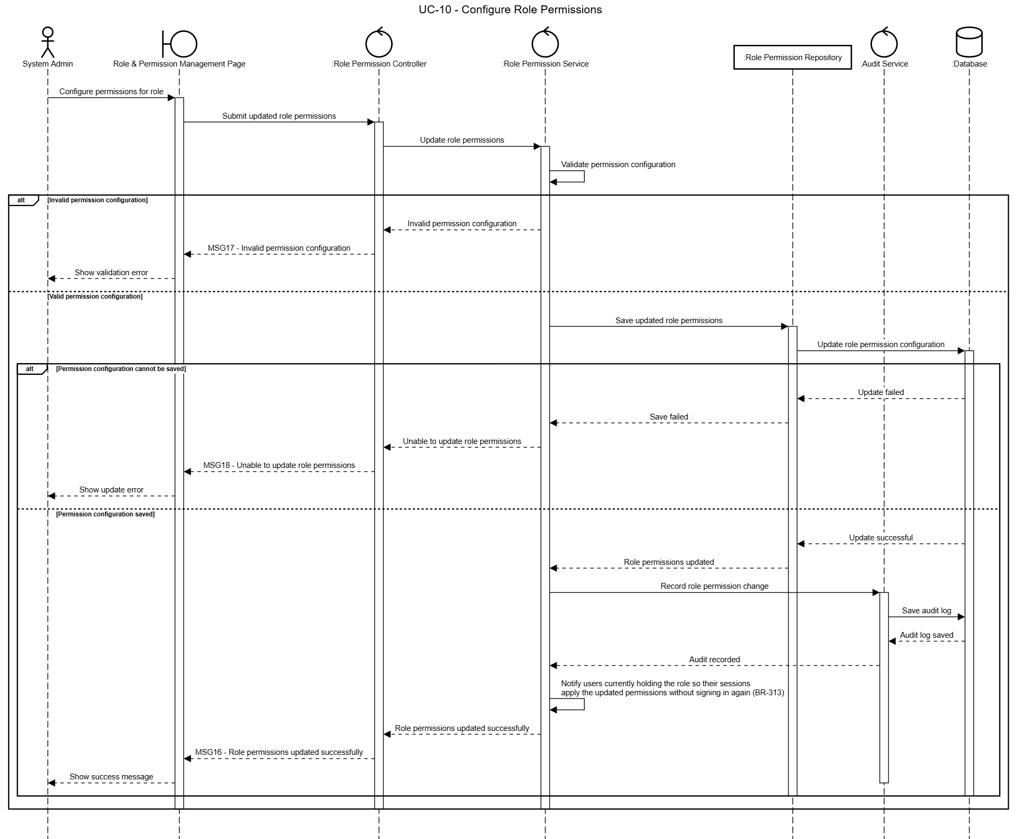

3.2.3 UC-12a – Create Role
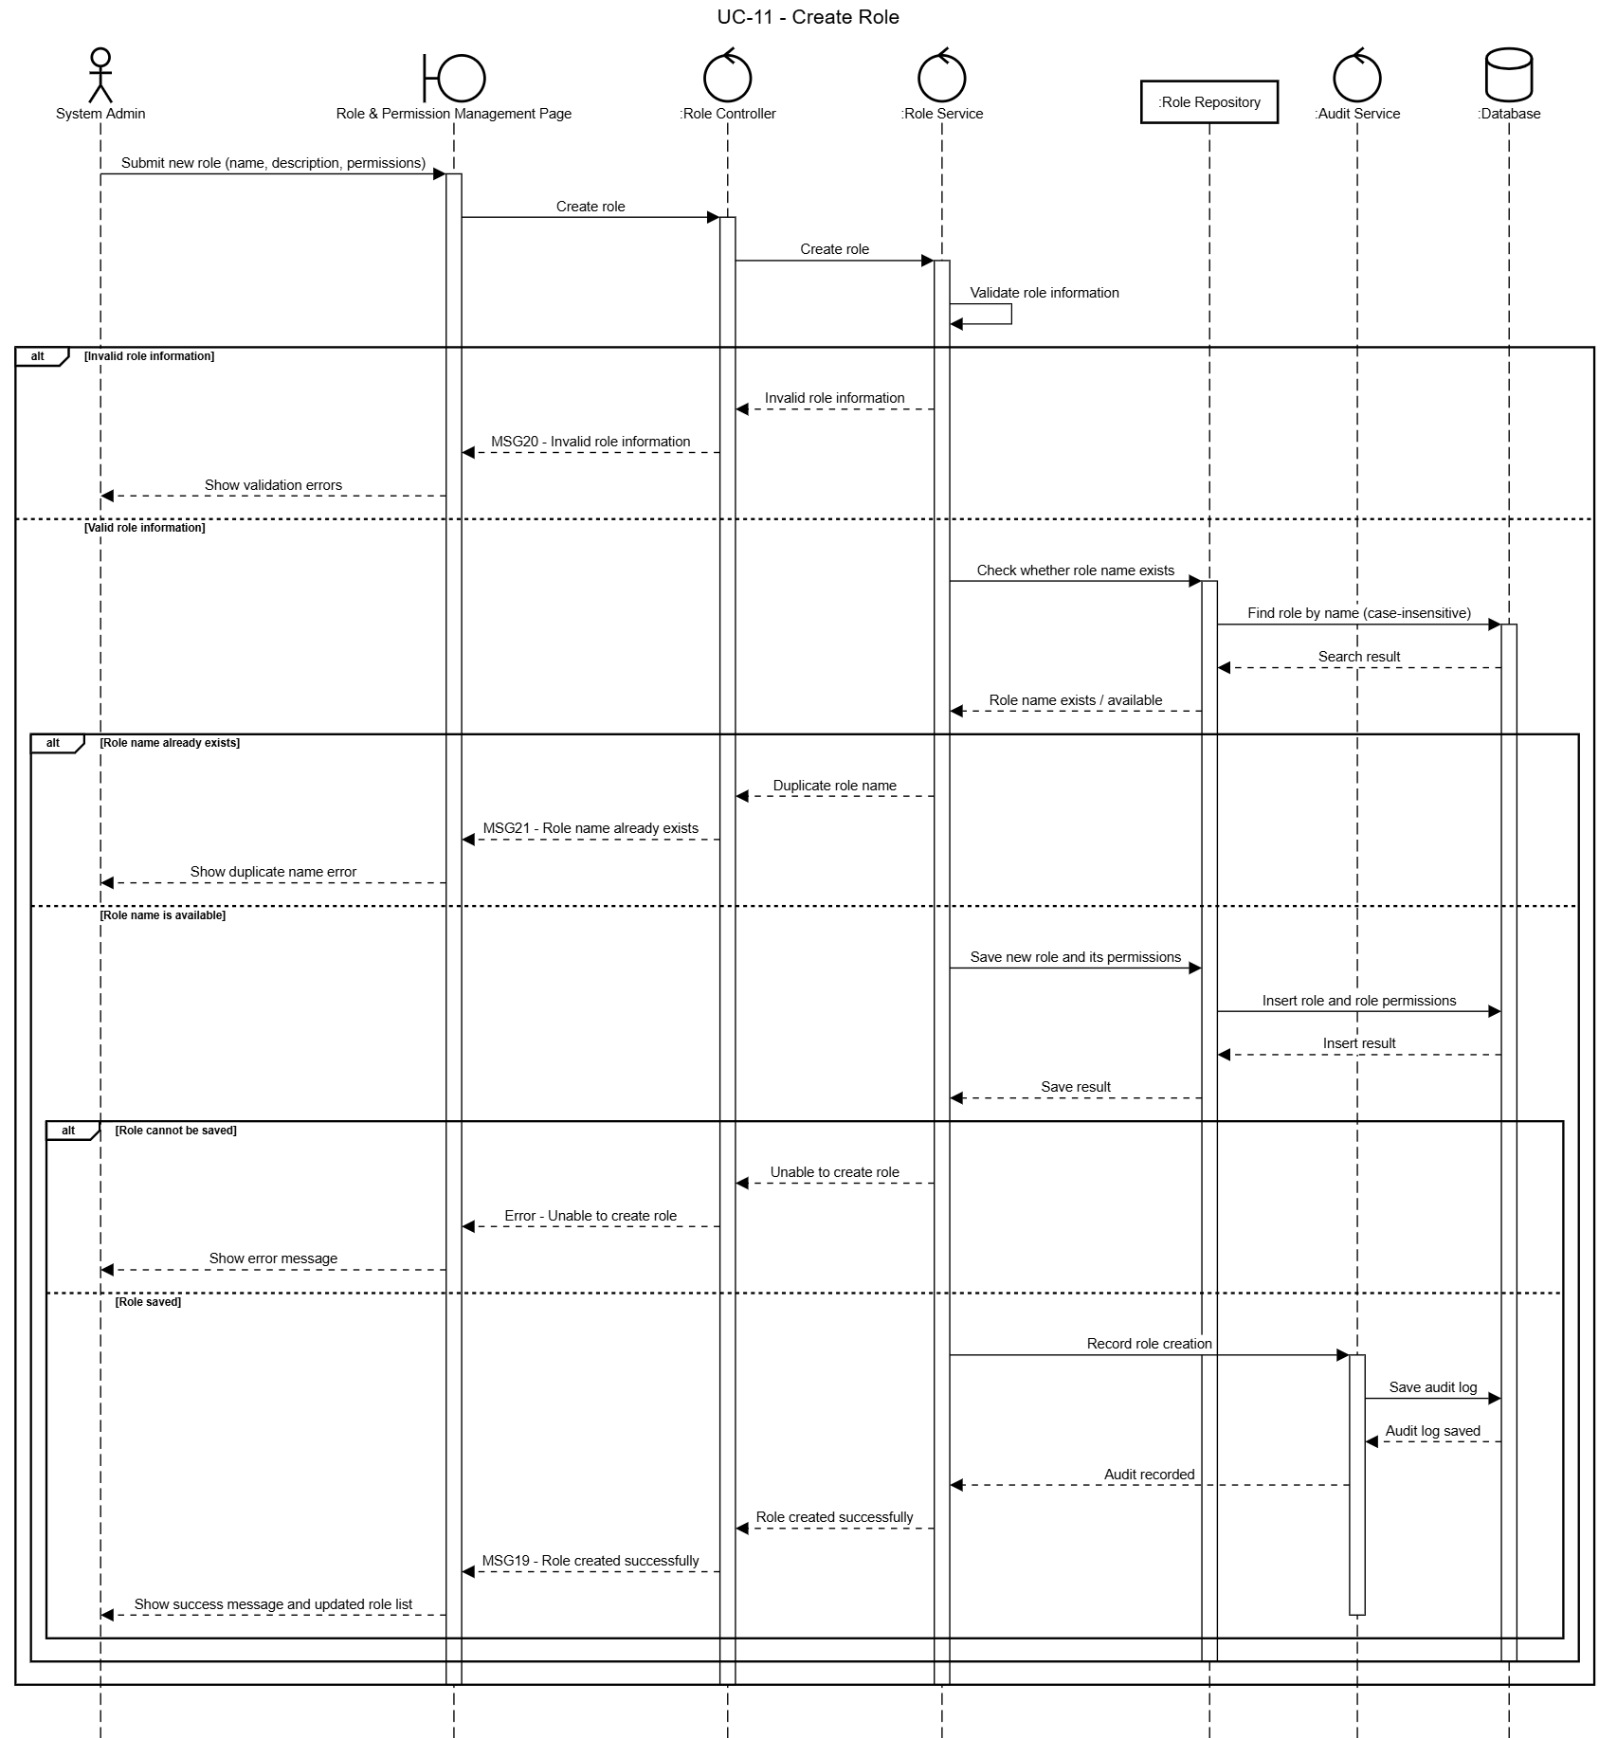

3.2.4 UC-12b – Update Role
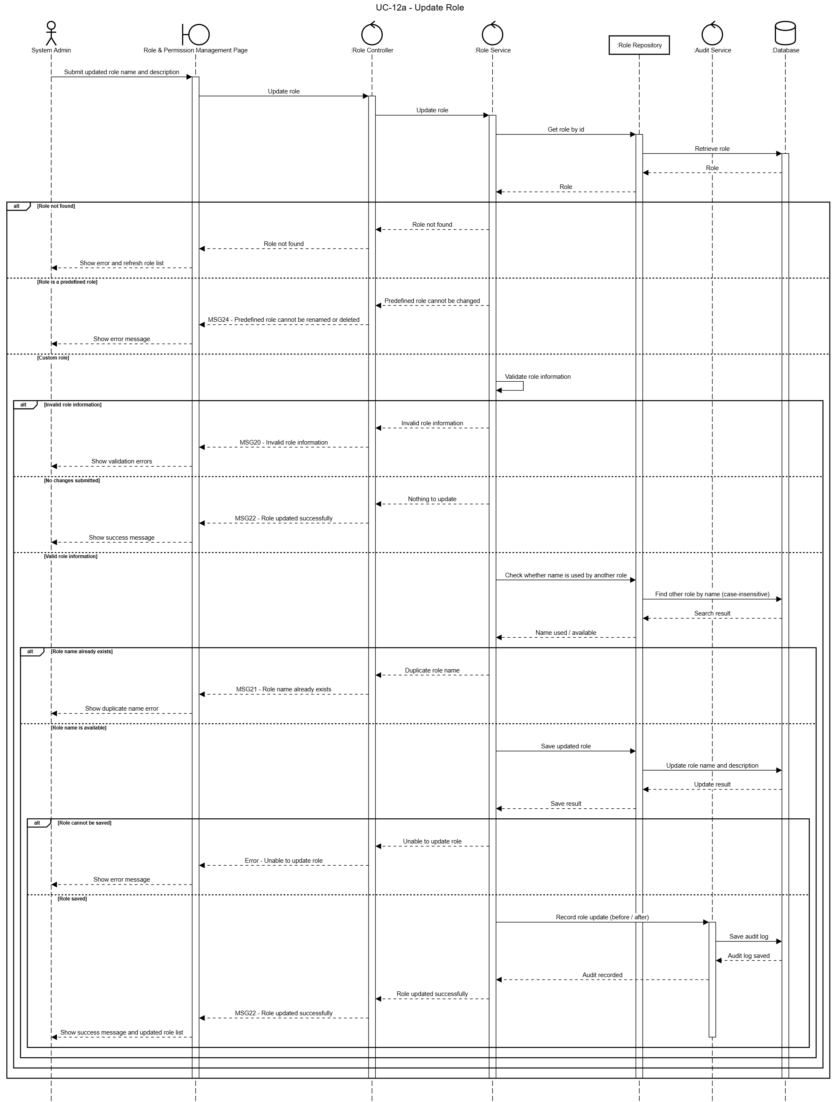

3.2.5 UC-12c – Delete Role
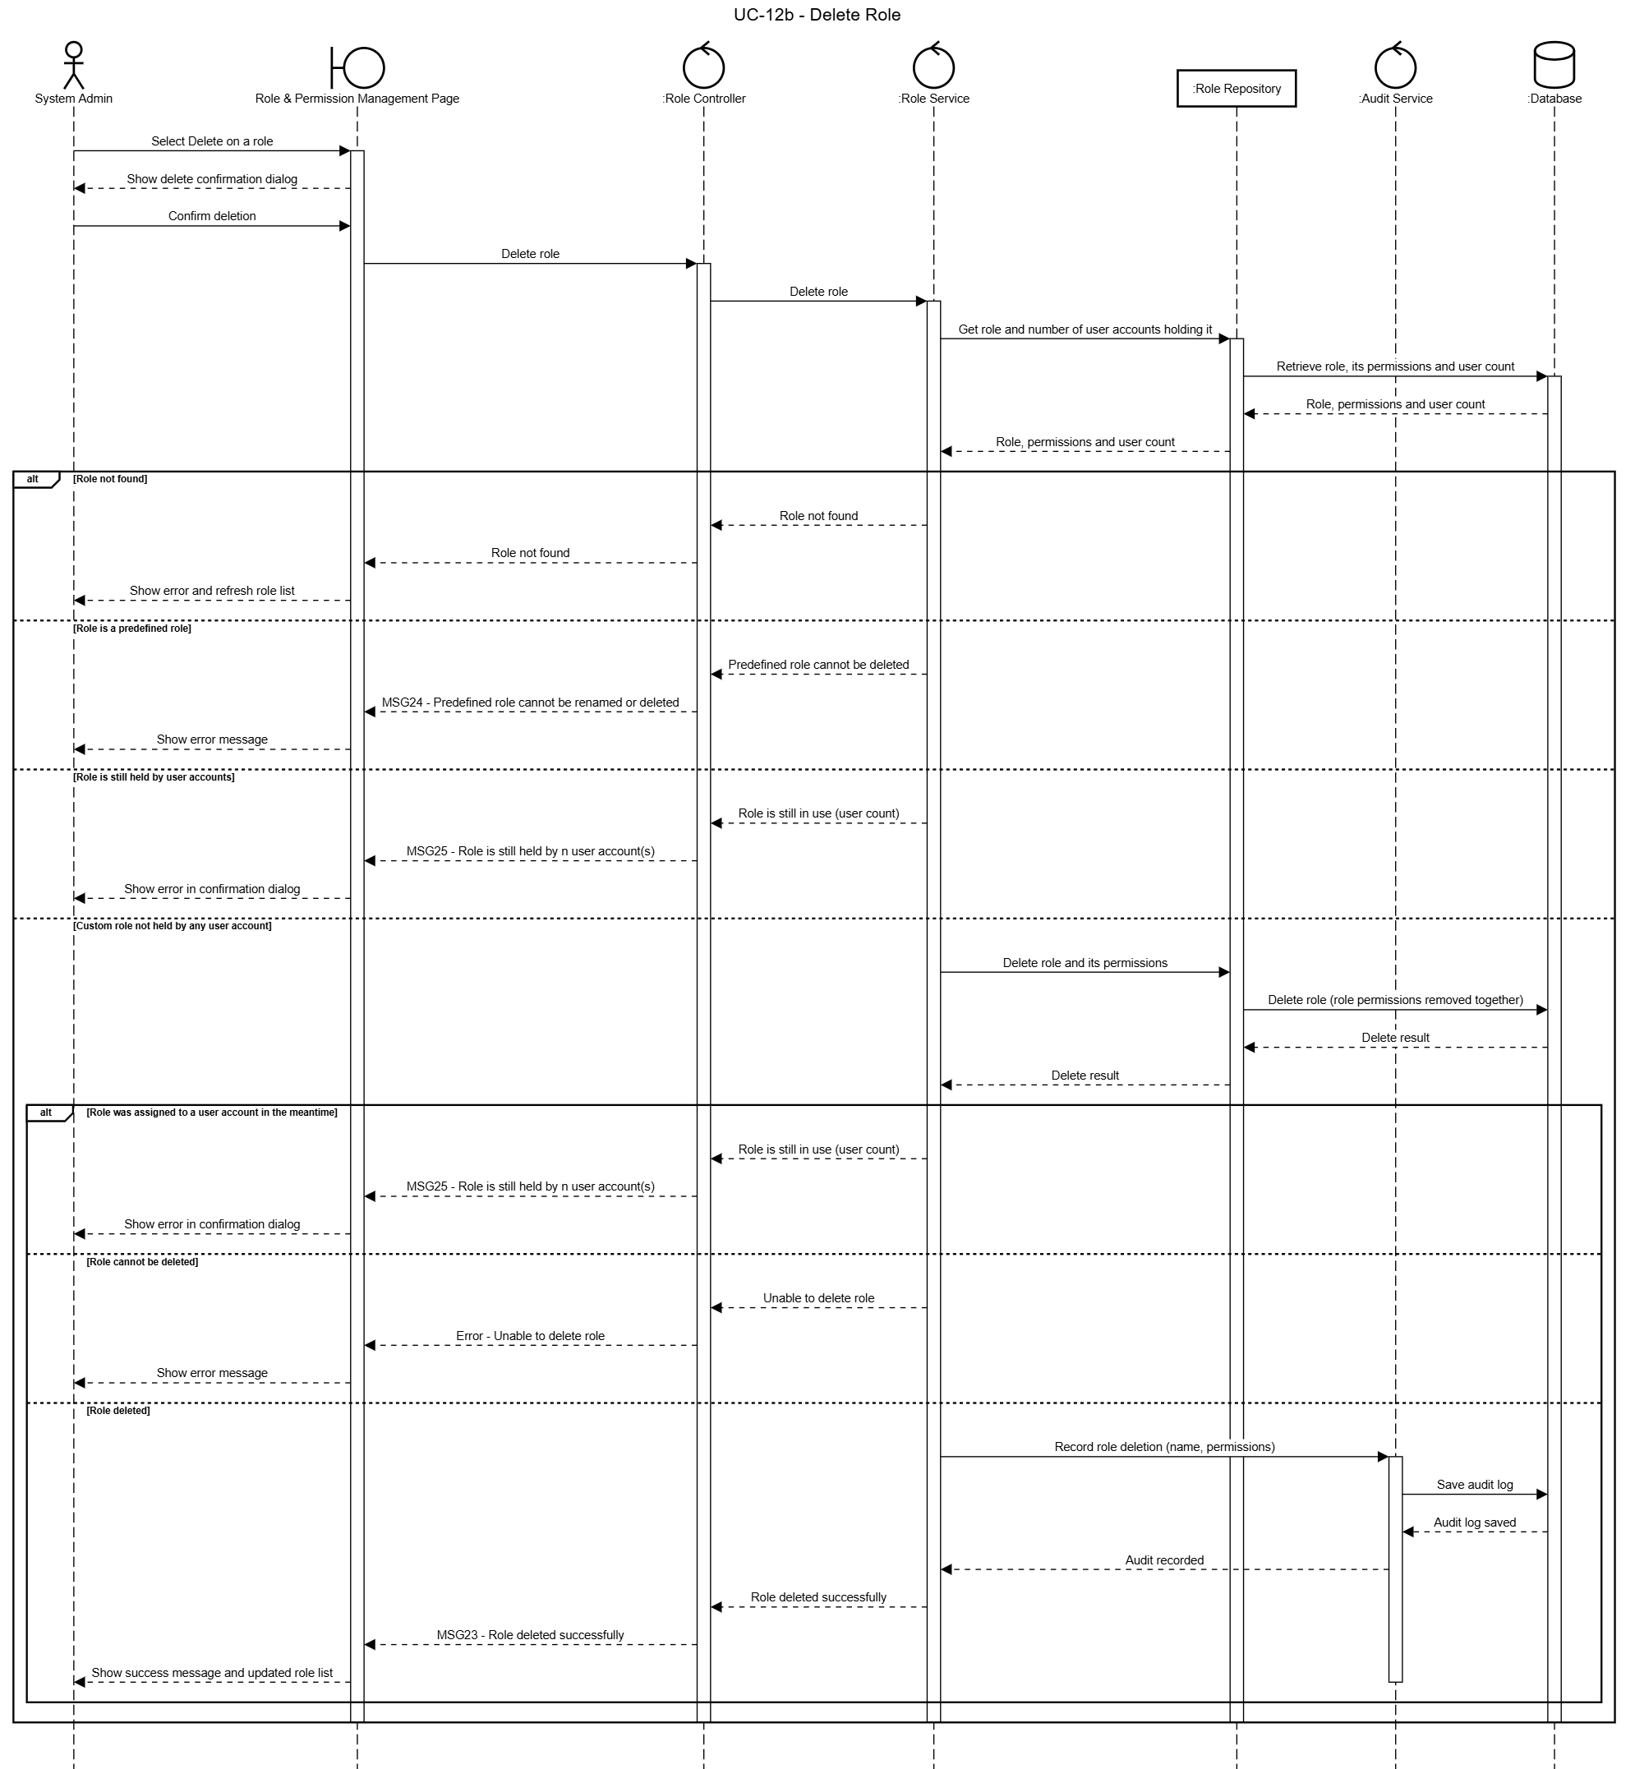

3.2.6 UC-13 – View Audit Log
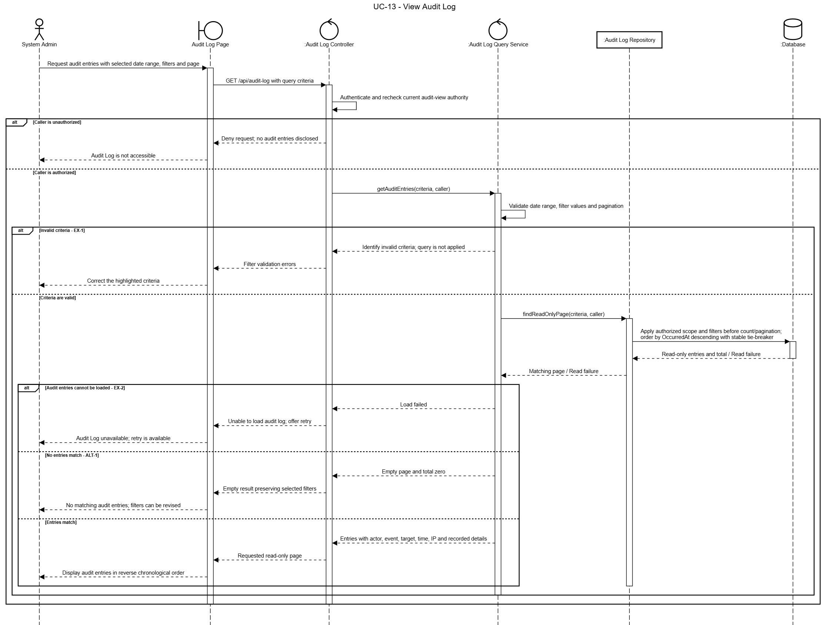

4. FE-04 Meeting Management

4.1 Class Diagram
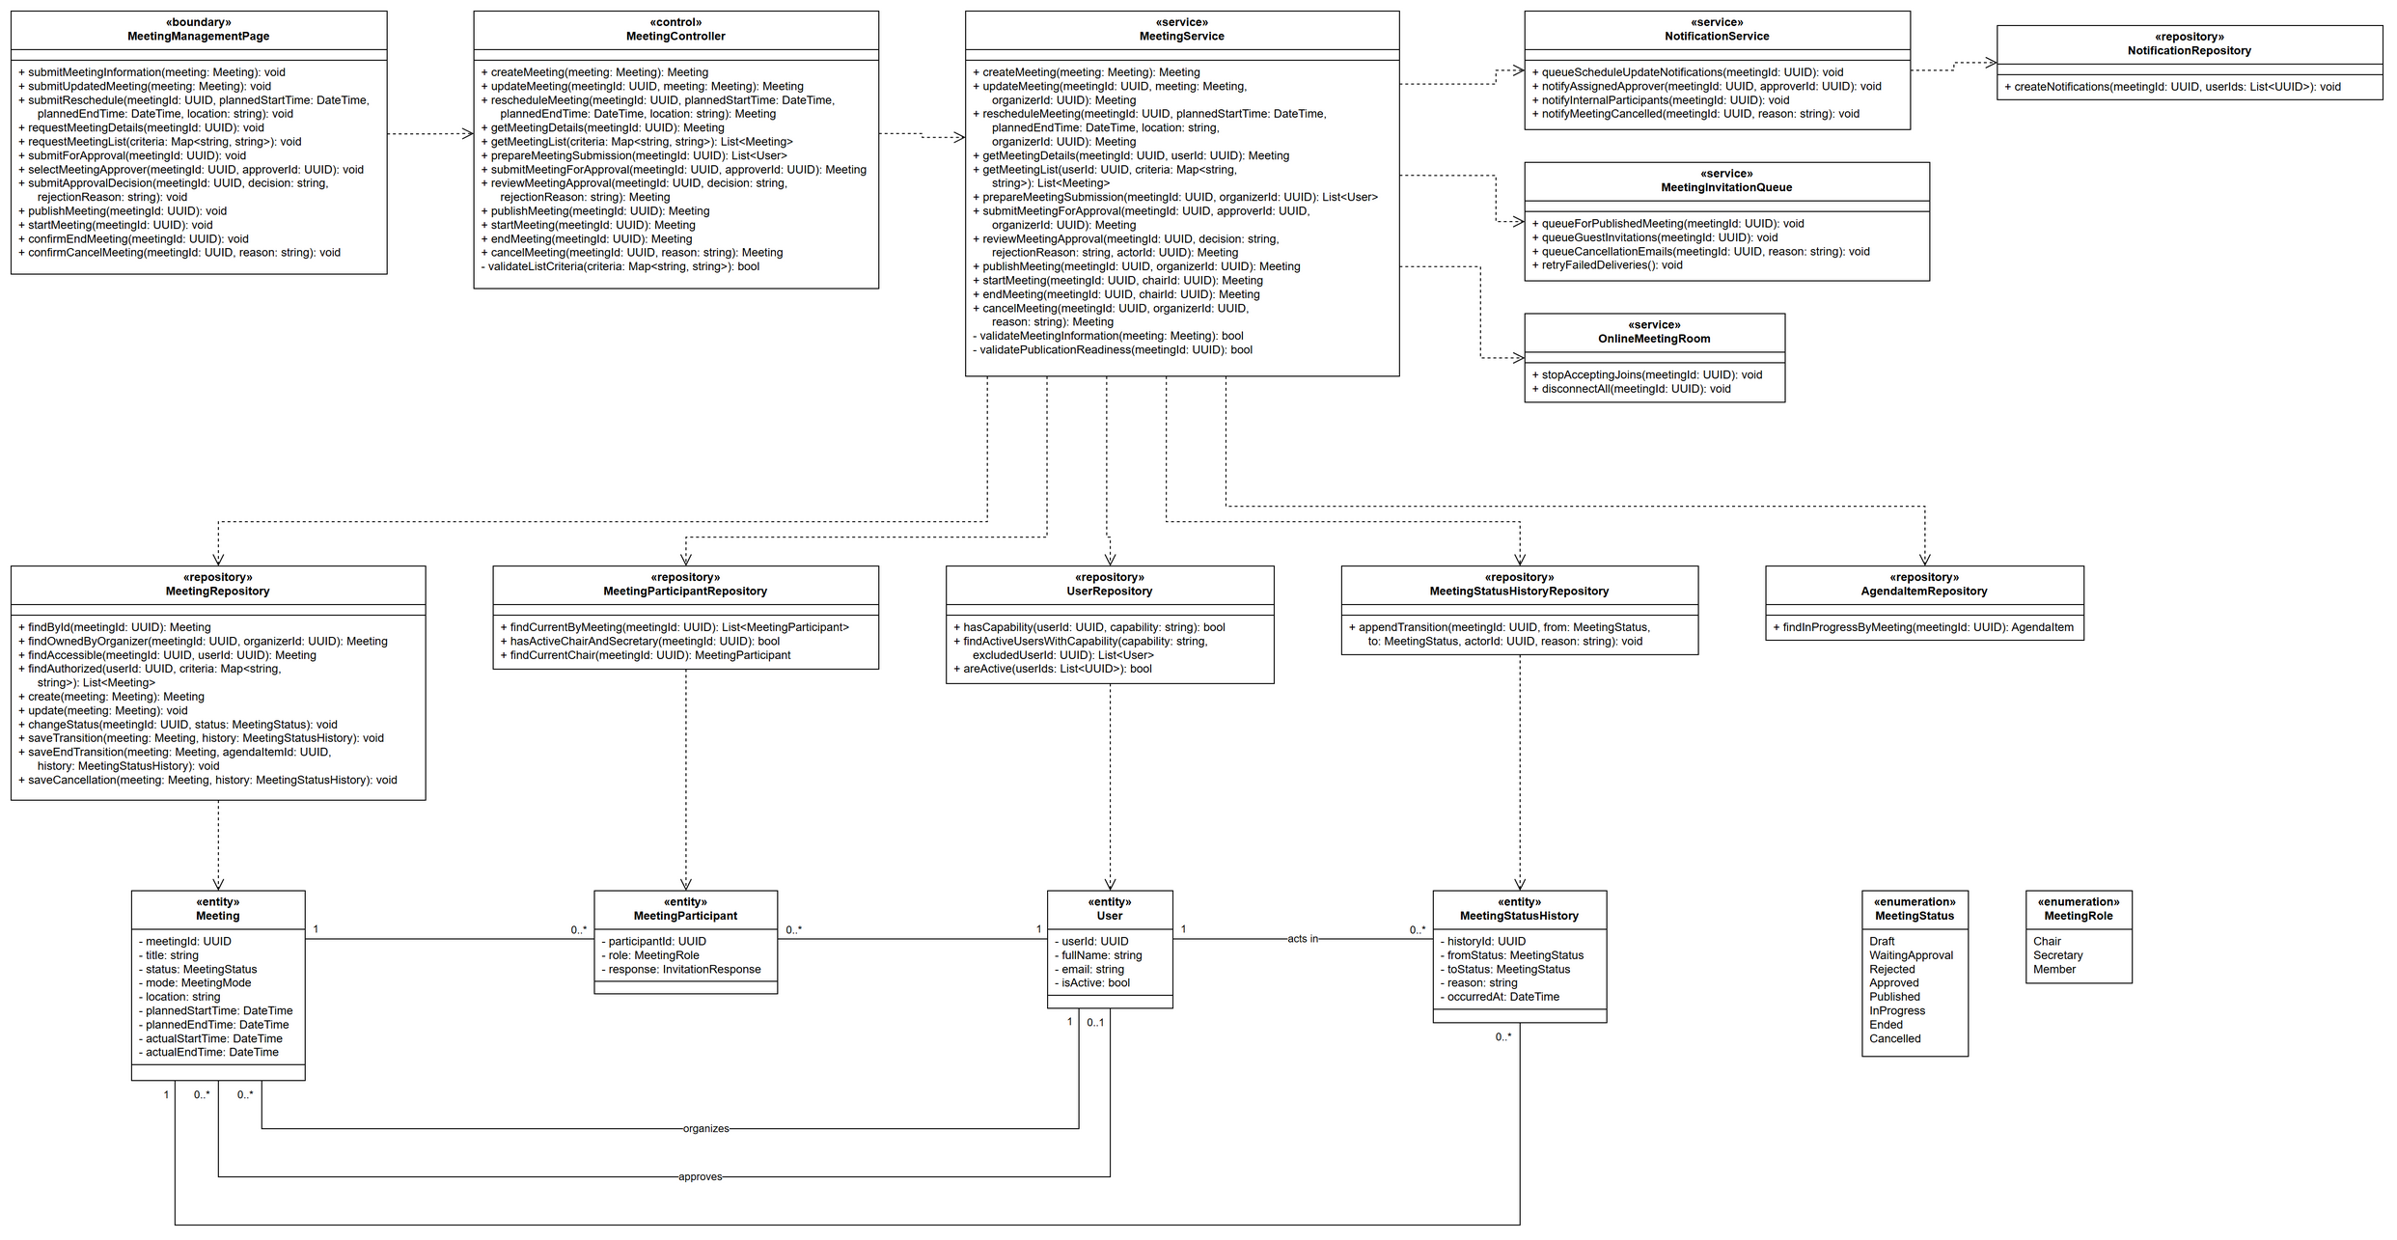

4.2 Sequence Diagram

4.2.1 UC-14 – Create Meeting
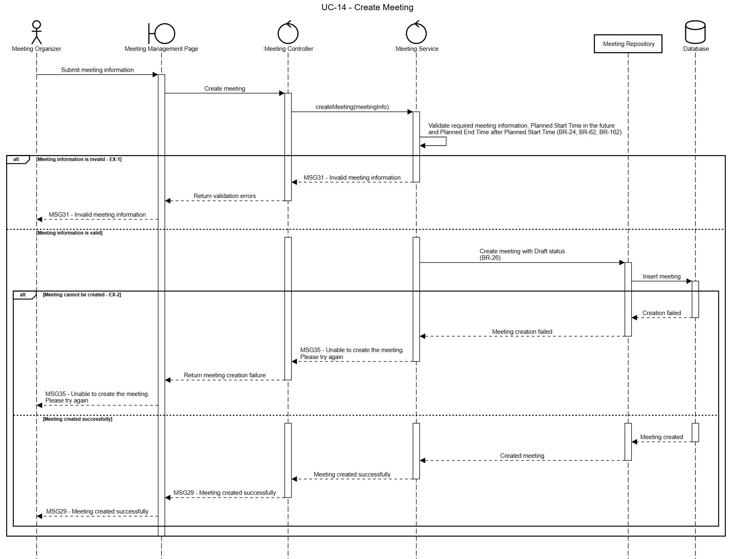

4.2.2 UC-15 – Update Meeting
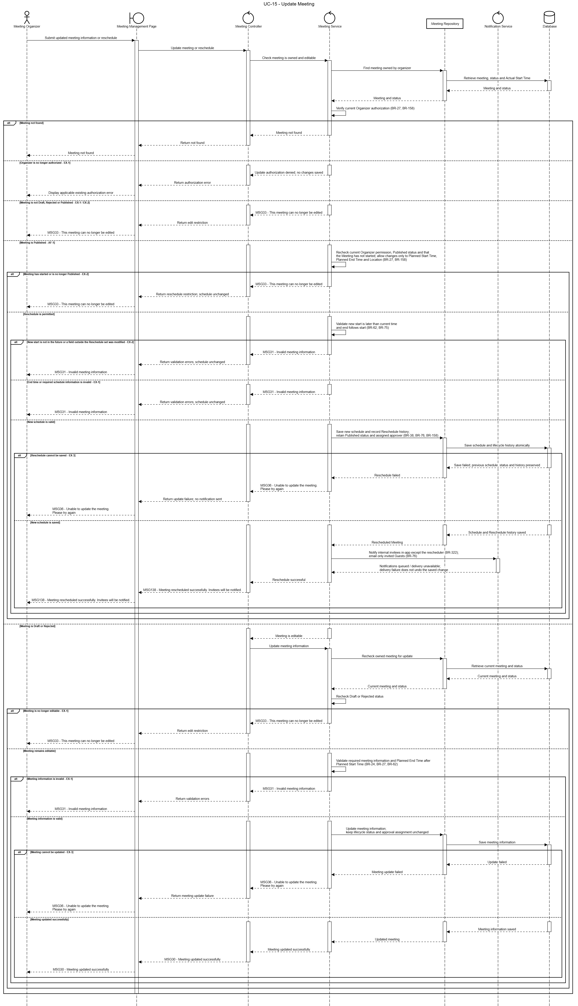

4.2.3 UC-16 – View Meeting Details
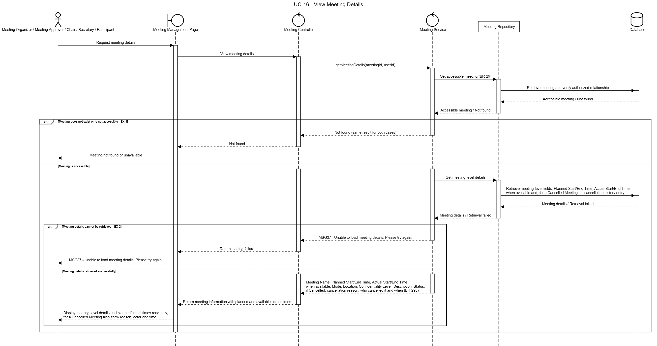

4.2.4 UC-17 – View Meeting List
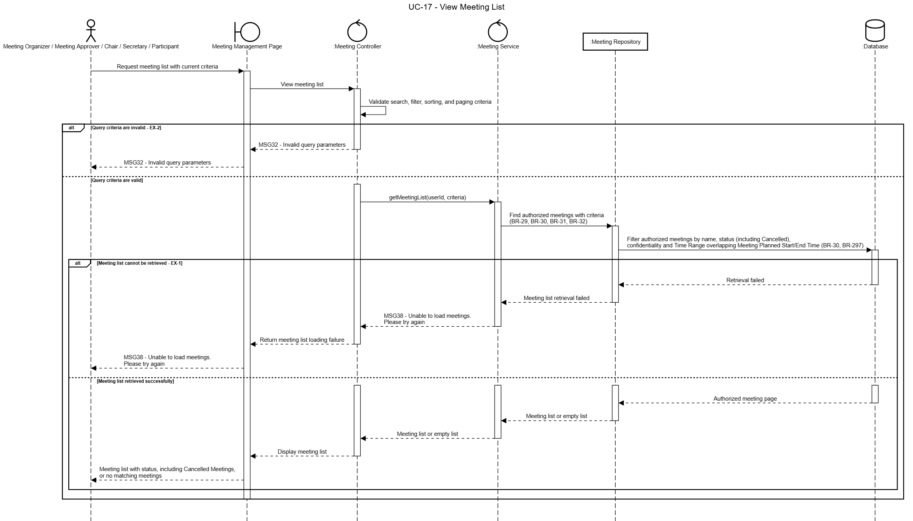

4.2.5 UC-18 – Submit Meeting for Approval
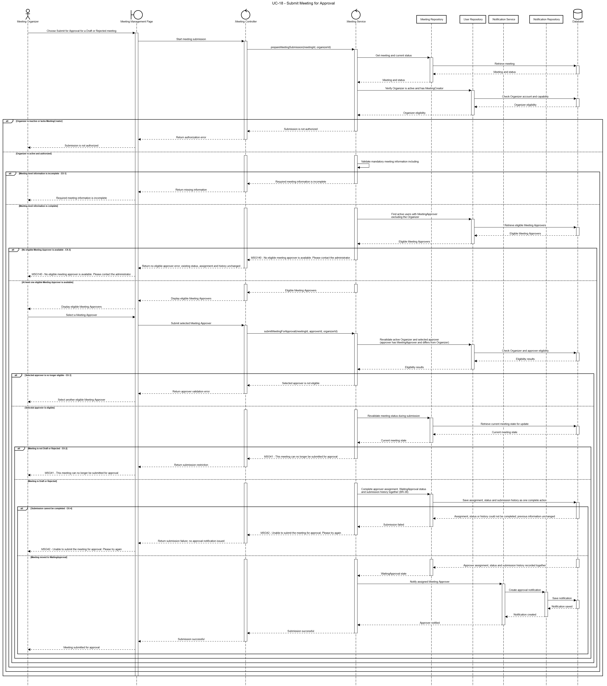

4.2.6 UC-19 – Review Meeting Approval
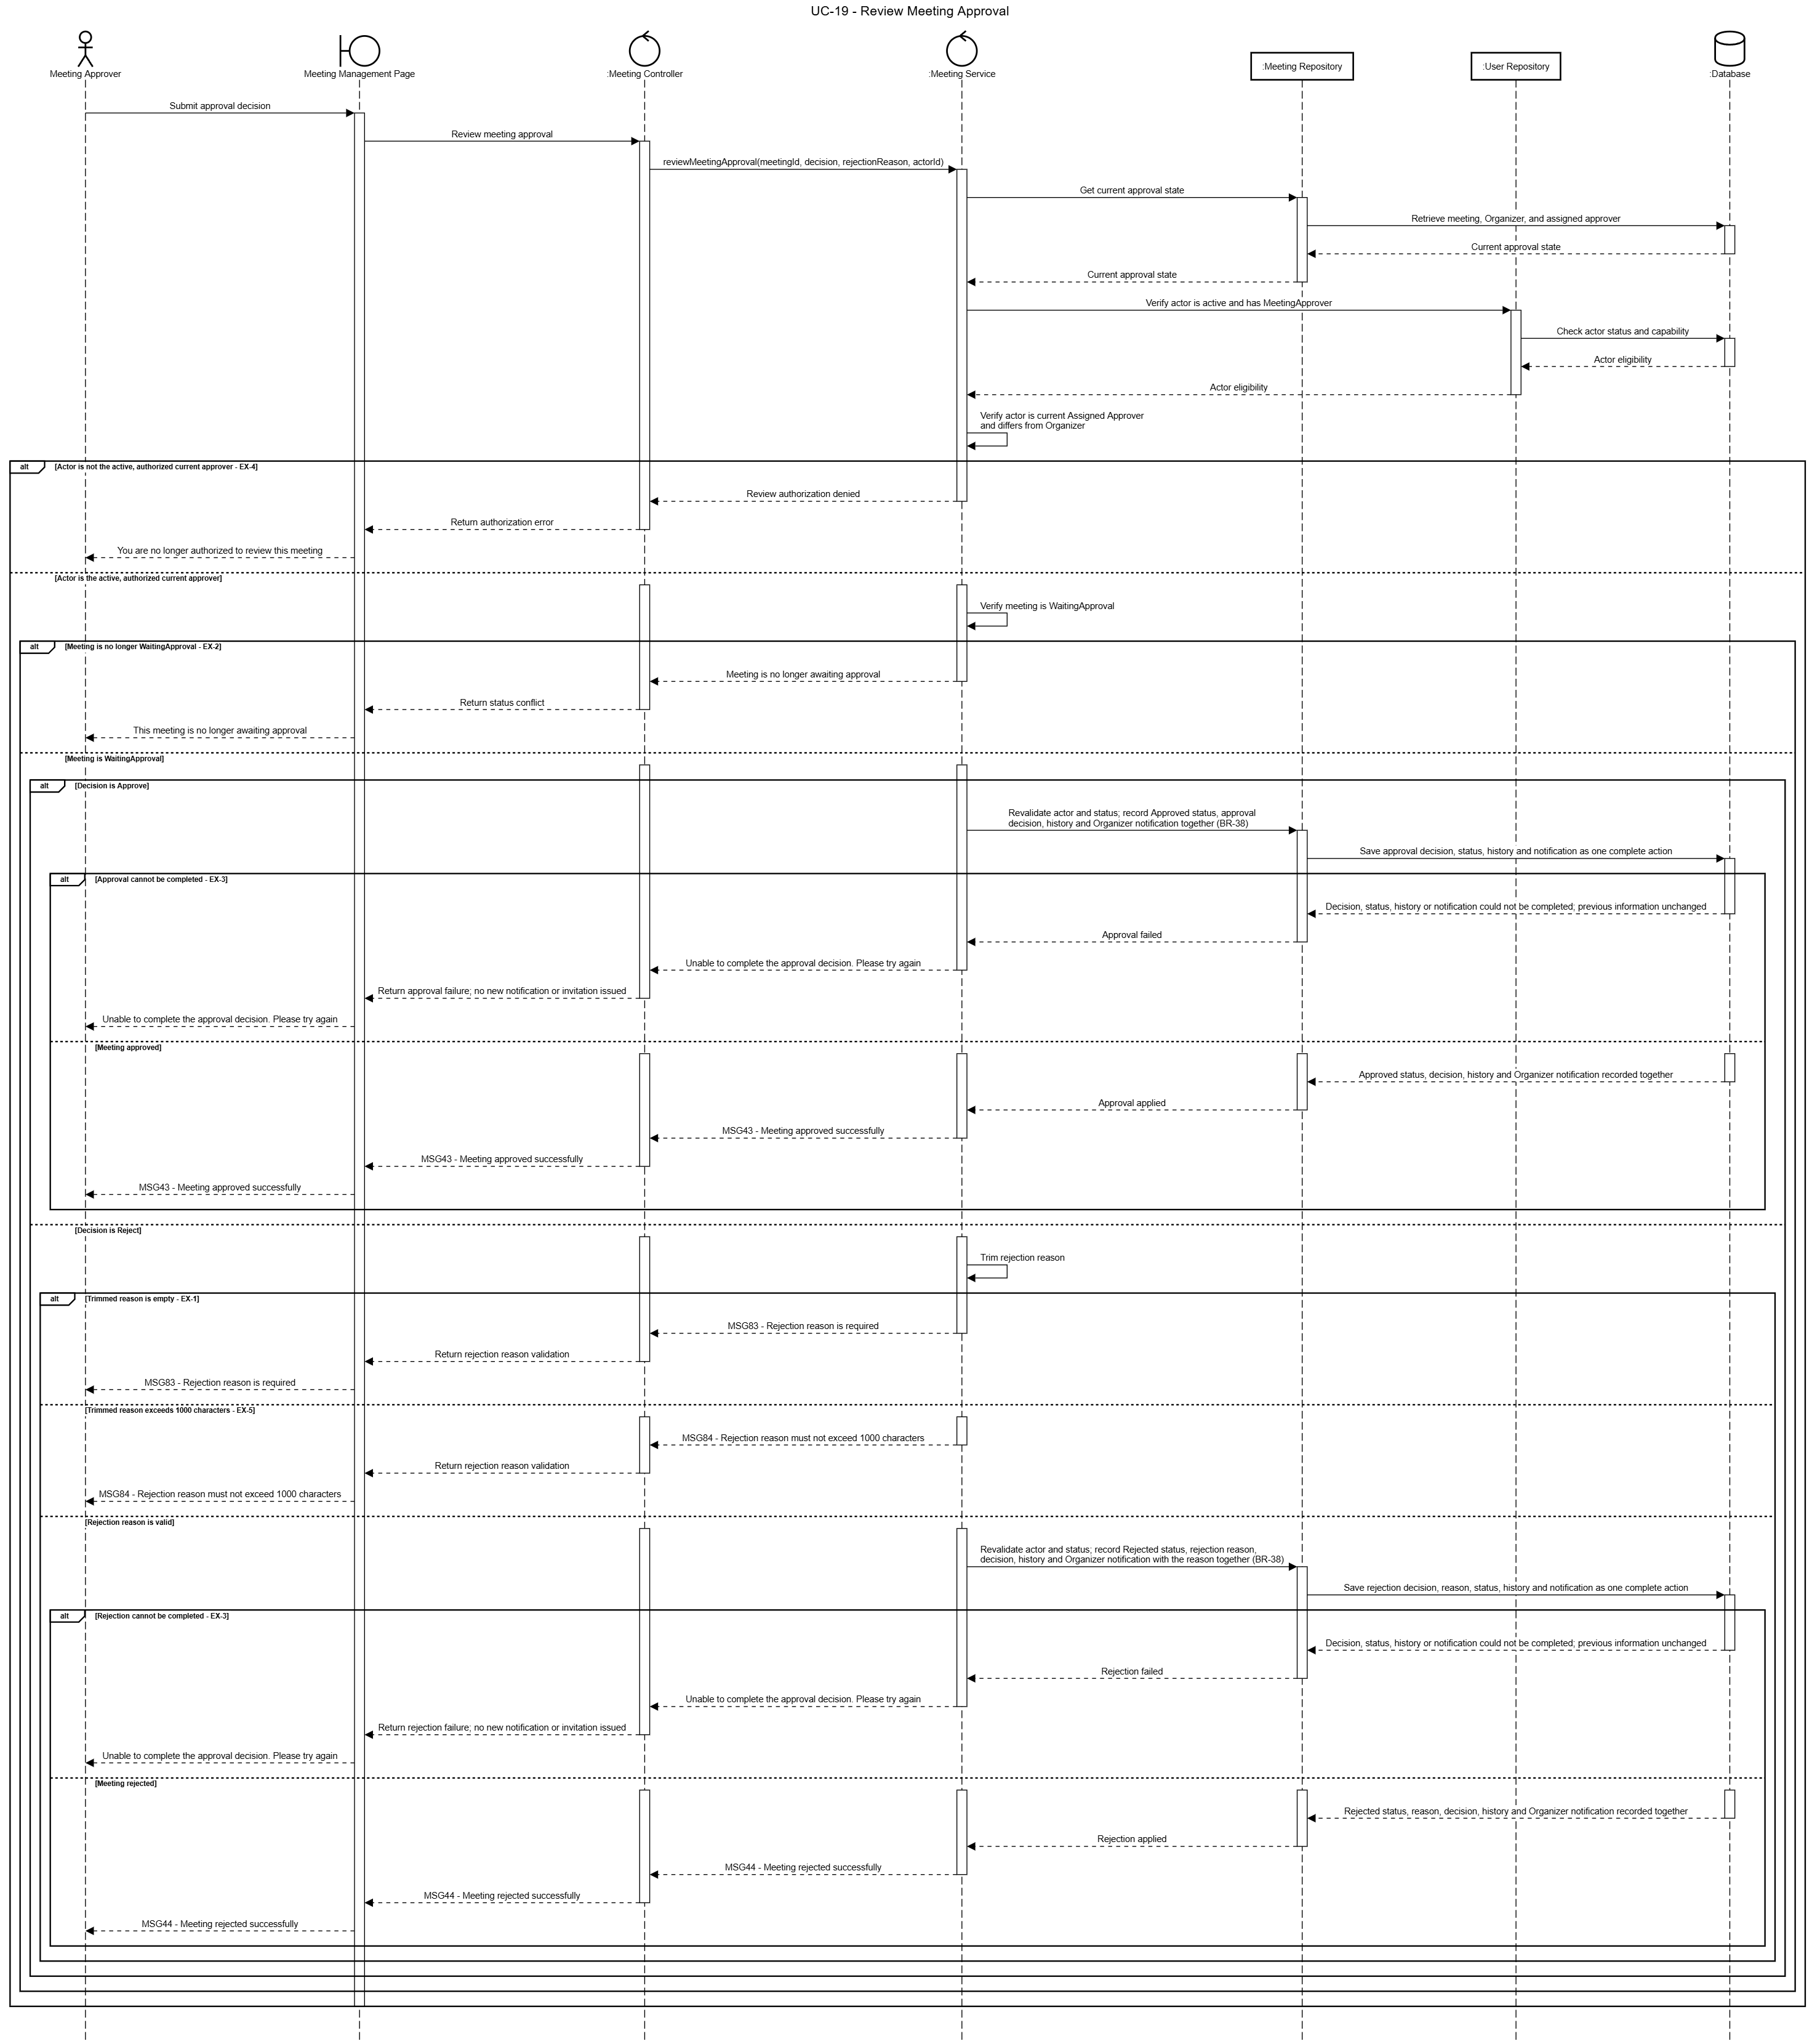

4.2.7 UC-20 – Publish Meeting
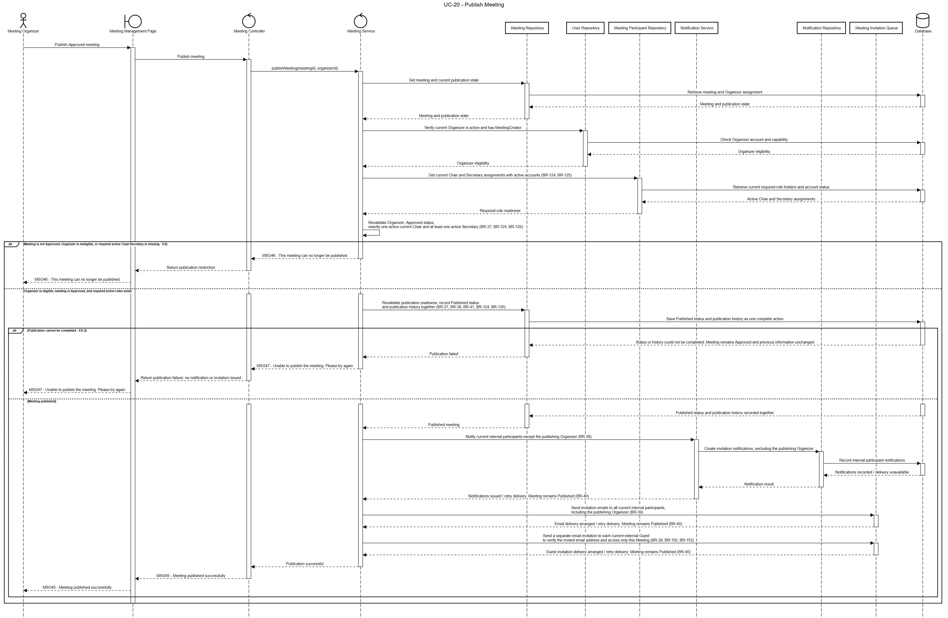

4.2.8 UC-21 – Start Meeting
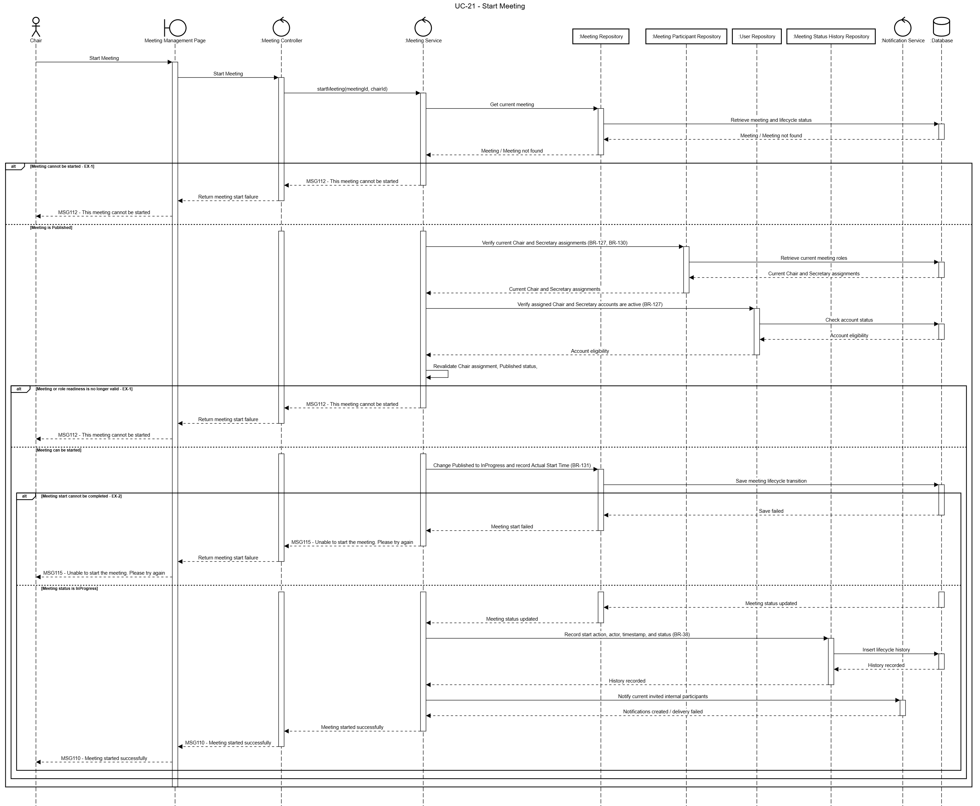

4.2.9 UC-22 – End Meeting
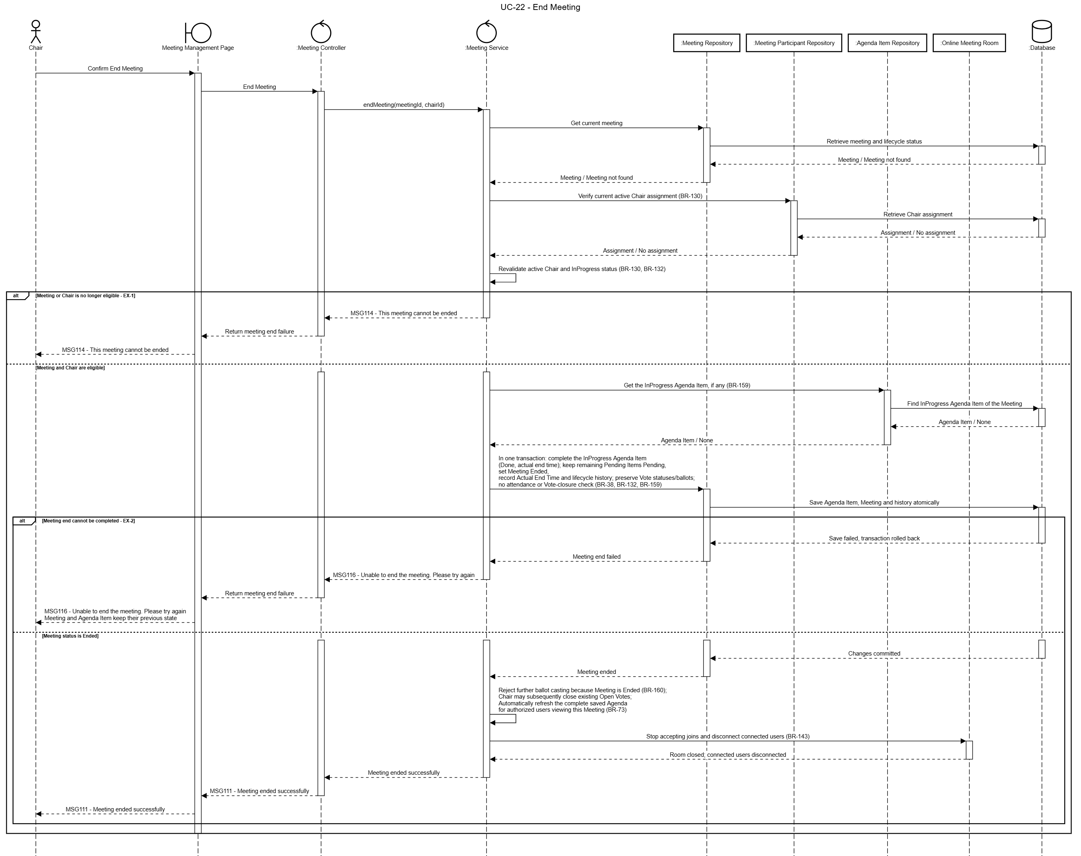

4.2.10 UC-75 – Cancel Meeting
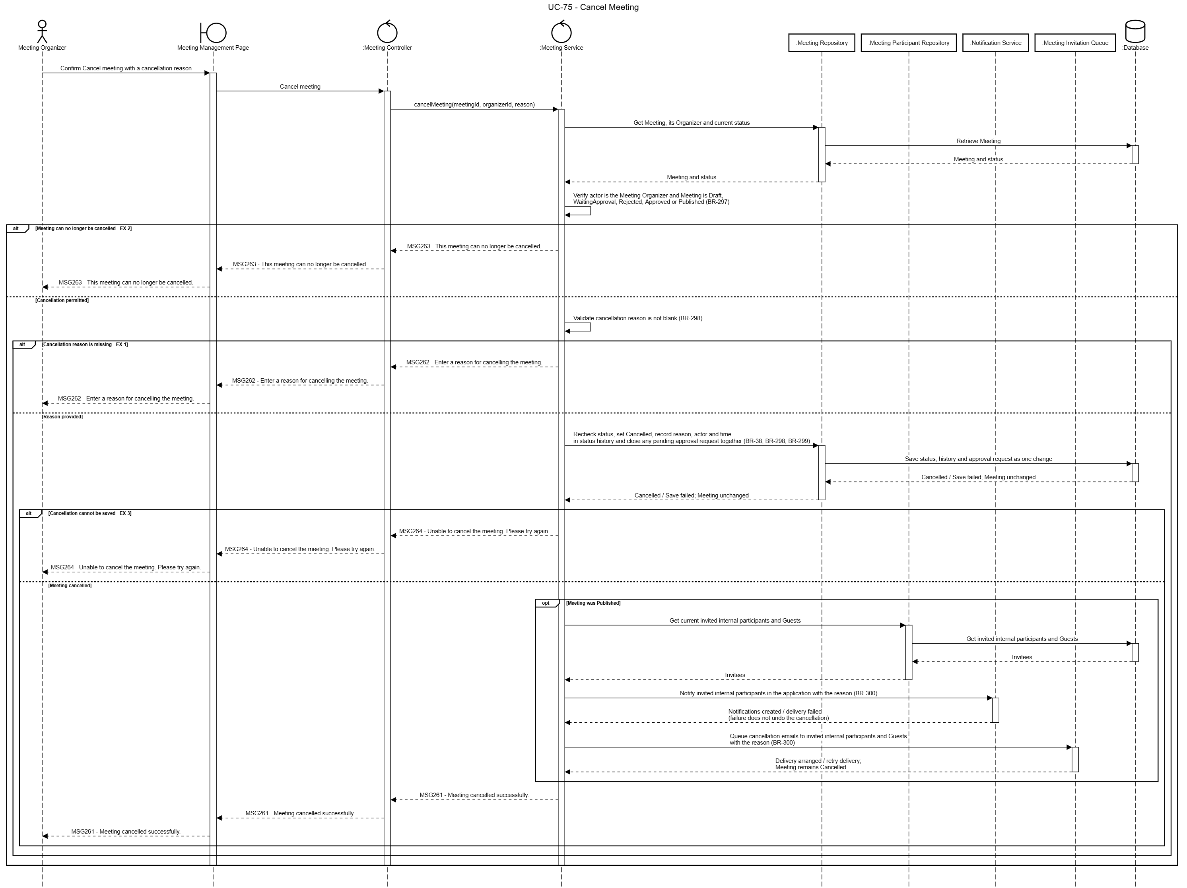

5. FE-05 Agenda Management

5.1 Class Diagram
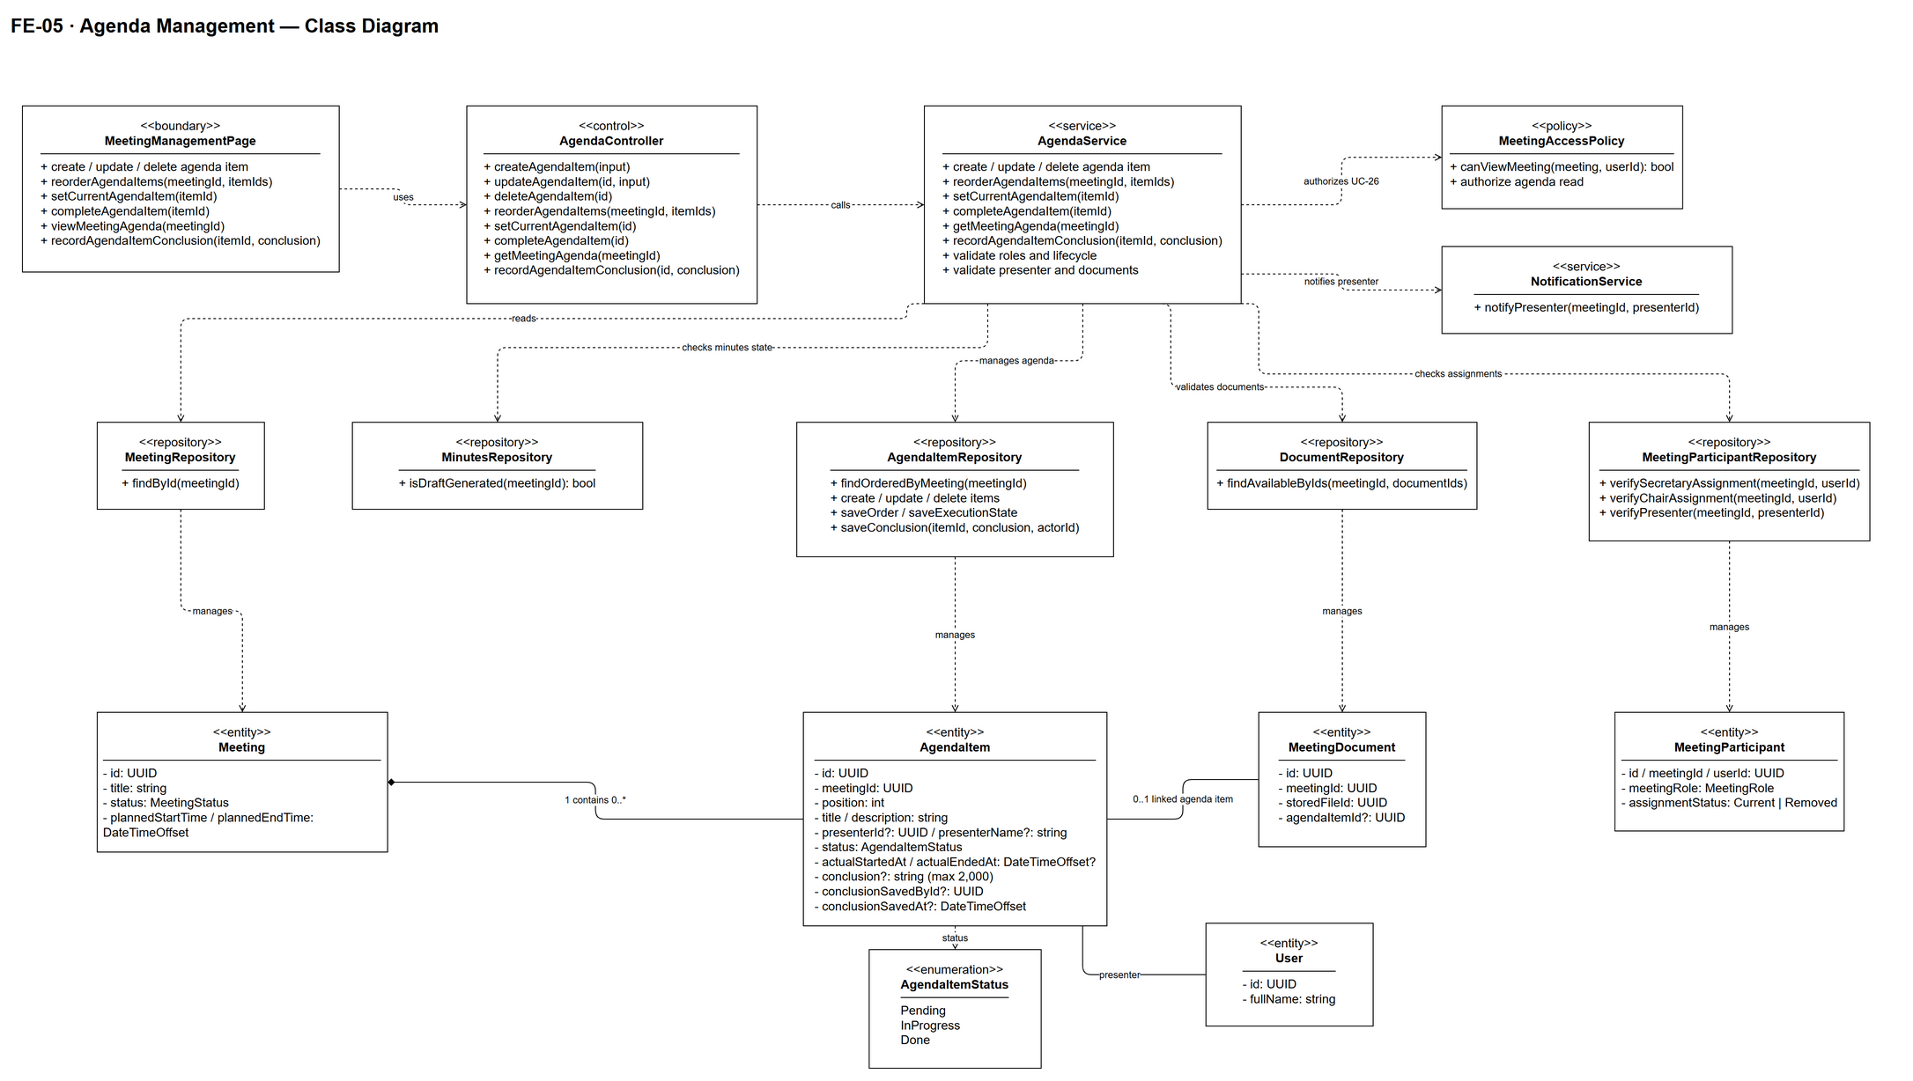

5.2 Sequence Diagram

5.2.1 UC-23a – Create Agenda Item

5.2.2 UC-23b – Update Agenda Item

5.2.3 UC-23c – Delete Agenda Item

5.2.4 UC-23d – Reorder Agenda Items

5.2.5 UC-24 – Set Current Agenda Item

5.2.6 UC-25 – Complete Agenda Item

5.2.7 UC-26 – View Meeting Agenda

5.2.8 UC-77 – Record Agenda Item Conclusion

6. FE-06 Meeting Participant Management

6.1 Class Diagram

6.2 Sequence Diagram

6.2.1 UC-27 – View Meeting Participants

6.2.2 UC-28a – Add Meeting Participant

6.2.3 UC-28b – Manage Meeting Role & Additional Permissions

6.2.4 UC-28c – Remove Meeting Participant

6.2.5 UC-29 – Respond to Meeting Invitation

6.2.6 UC-30 – View Participant Response Status

6.2.7 UC-31 – Record Attendance

6.2.8 UC-73 – Hand Over Chair to Another Participant

7. FE-07 Meeting Document Management

7.1 Class Diagram

7.2 Sequence Diagram

7.2.1 UC-32a – View Meeting Documents

7.2.2 UC-32c – Preview Meeting Document

7.2.3 UC-33a – Add Documents from Personal Library

7.2.4 UC-33a – Upload Documents to Meeting (AF-1)

7.2.5 UC-33b – Attach Documents to Agenda Item

7.2.6 UC-33c – Remove Document from Meeting

7.2.7 UC-33d – Detach Document from Agenda Item

7.2.8 UC-34 – View Personal Document Library

7.2.9 UC-34b – View a Locked Account's Personal Library

7.2.10 UC-35 – Comment on Meeting Document

7.2.11 UC-36 – Upload Document to Personal Library

7.2.12 UC-71a – Delete Document from Personal Library

7.2.13 UC-71b – Rename Document

7.2.14 UC-71c – Move Document to Folder

7.2.15 UC-72a – Create Folder

7.2.16 UC-72b – Rename Folder

7.2.17 UC-72c – Move Folder

7.2.18 UC-72d – Delete Folder

7.2.19 UC-74 – Confirm Document Read

8. FE-11 Voting Management

8.1 Sequence Diagram

8.1.1 UC-76a – Attach Documents to Vote

8.1.2 UC-76b – Detach Document from Vote

9. FE-13 Notification

9.1 Class Diagram

9.2 Sequence Diagram

9.2.1 UC-66 – View Notifications

9.2.2 UC-67a – Mark Notification as Read

9.2.3 UC-67b – Mark All Notifications as Read

9.2.4 UC-68 – Open Notification Target

III. Design for Non-Functional Requirements
[Provide design specifications for non functional requirements in the similar way as samples below]

1. Security Design

1.1 Authentication Flow
TalentHub v2 uses stateless JWT-based authentication. The React SPA stores tokens in memory (not localStorage) to mitigate XSS. A refresh token is stored in an HttpOnly cookie. The Spring Security filter chain validates the access token on every protected request.

a. Token Design
Aspect | Design Decision
Token format | JWT — RS256 (asymmetric — private key signs, public key verifies)
Access token expiry | 15 minutes — short window limits exposure if intercepted
Refresh token expiry | 7 days — stored as HttpOnly, SameSite=Strict, Secure cookie
…

b. CORS Configuration
CORS is required because the React SPA (e.g. https://app.shopeasy.vn) and the Spring Boot API (e.g. https://api.talenthub.vn) run on different origins in production.
Environment | Allowed Origins | Allowed Methods | Allow Credentials | Max Age
Development | http://localhost:5173 | GET, POST, PUT, PATCH, DELETE, OPTIONS | true (needed for HttpOnly cookie) | 3600s
Staging | https://staging.talenthub.vn | GET, POST, PUT, PATCH, DELETE, OPTIONS | TRUE | 3600s
Production | https://app.talenthub.vn | GET, POST, PUT, PATCH, DELETE, OPTIONS | TRUE | 86400s

1.2 Authorization & RBAC Implementation
Aspect | Decision
RBAC implementation | Spring Security @PreAuthorize('hasRole(...)') on @RestController methods; SecurityConfig configures /api/v1/auth/** as public; all /api/v1/** requires authenticated
Role hierarchy | ADMIN > MANAGER > RECRUITER > CANDIATE— Spring Security RoleHierarchyImpl configured in SecurityConfig
…

1.3 Data Protection
Data Category | At Rest | In Transit | Notes
Passwords | bcrypt cost 12 (NFR-SEC02) | TLS | Never logged; never returned in API responses
Payment data | Not stored (NFR-SEC03) | TLS | VNPay/MoMo handle capture; TalentHub stores event_id + result only
API keys (external) | Environment variables / cloud secrets | TLS | Never in source code; never logged

2. Performance & Scalability Design

2.1 Caching Strategy
What is Cached | Redis Key | TTL | Invalidation Trigger | NFR
Application list (per filter combo) | cache:application:  list:{hash} | 30s | On any application status change in that shop | NFR-P01 — avoids DB hit on 60s polling
Job detail | cache:job:{job_id} | 10 min | On JOB threshold update or re-activation | NFR-P01
…
…

2.2 Database Query Optimization
…

IV. Other Design Specifications
[Provide any other design specifications here: data design, system integrations, algorithms, etc.]
…

